U.S. SECURITIES AND EXCHANGE COMMISSION Washington, DC 20549
FORM 10-K
(Mark one)

[X] | ANNUAL REPORT PURSUANT TO SECTION 13 OR 15(d) OF THE SECURITIES EXCHANGE ACT OF 1934  For the fiscal year ended: November 30, 2012
[ ] | TRANSITION REPORT UNDER SECTION 13 OR 15(d) OF THE SECURITIES EXCHANGE ACT OF 1934  For the transition period from ______ to ______  Commission file number: 0-31555
BAB, Inc.
(Exact name of registrant as specified in its charter)
Delaware | 36-4389547
(State or other jurisdiction of incorporation) | (IRS Employer or organization Identification No.)
500 Lake Cook Road, Suite 475 Deerfield, Illinois 60015
(Address of principal executive offices) (Zip Code)
Registrant’s telephone number: (847) 948-7520

Securities registered pursuant to Section 12(b) of the Act:
Title of each class Name of exchange on which registered
Common Stock NASDAQ/OTC

Securities registered pursuant to Section 12(g) of the Act:
None
(Title of Class)

Indicate by check mark if the issuer is a well-known seasoned issuer, as defined in Rule 405 of the Securities Act. [ ] Yes [X ] No

Indicate by check mark whether the issuer is not required to file reports pursuant to Section 13 or 15(d) of the Exchange Act. [ ] Yes [ X] No

Indicate by check mark whether the registrant (1) has filed all reports required to be filed by Section 13 or 15(d) of the Securities Exchange Act of 1934 during the preceding 12 months (or for such shorter period that the registrant was required to file such reports), and (2) has been subject to such filing requirements for the past 90 days. [X] Yes [ ] No

Indicate by check mark whether the registrant has submitted electronically and posted on its corporate Web site, if any, every Interactive Data File required to be submitted and posted pursuant to Rule 405 of Regulation S-T during the preceding 12 months (or for such shorter period that the registrant was required to submit and post such files). [X] Yes [ ] No

Indicate by check mark if disclosure of delinquent filers pursuant to Item 405 of Regulation S-K is not contained herein, and will not be contained, to the best of registrant’s knowledge, in definitive proxy or information statements incorporated by reference in Part III of this Form 10-K or any amendment to this Form 10-K.[ ]

Indicate by check mark whether the registrant is a large accelerated filer, an accelerated filer, a non-accelerated filer, or a smaller reporting company. See the definitions of “large accelerated filer,” “accelerated filer” and “smaller reporting company” in Rule 12b-2 of the Exchange Act (check one): Large Accelerated Filer [ ], Accelerated Filer [ ], Non-Accelerated Filer [ ], Smaller Reporting Company [ X ].

Indicate by check mark whether the registrant is a shell company (as defined in Rule 12b-2 of the Exchange Act). Yes [ ] No [ X ]
State issuer's revenues for its most recent fiscal year: $2,674,822.
The aggregate market value of the voting common equity held by nonaffiliates as of the last business day of the registrant’s most recently completed second fiscal quarter was: $2,936,209 based on 4,735,820 shares held by nonaffiliates as of May 31, 2012; Closing price ($.62) for said shares in the NASDAQ OTC Bulletin Board as of such date.

State the number of shares outstanding of each of the issuer's classes of common equity, as of the latest practicable date: 7,263,508 shares of Common Stock, as of February 15, 2013.

DOCUMENTS INCORPORATED BY REFERENCE
See index to exhibits

FORM 10-K INDEX
PART I
Item 1 | Description of Business | 3
Item 1A | Risk Factors | 7
Item 1B | Unresolved Staff Comments | 7
Item 2 | Properties | 7
Item 3 | Legal Proceedings | 7
Item 4 | Mine Safety Disclosures | 7
PART II
Item 5. | Market for Registrant’s Common Equity, Related Stockholder Matters and Issuer Purchases of Equity Securities | 8
Item 6. | Selected Financial Data | 9
Item 7. | Management’s Discussion and Analysis of Financial Condition and Results of Operations | 9
Item 7A. | Quantitative and Qualitative Disclosures About Market Risk | 13
Item 8. | Financial Statements and Supplementary Data | 14
Item 9. | Changes in and Disagreement with Accountants on Accounting and Financial Disclosure | 32
Item 9A. | Controls and Procedures | 32
Item 9B | Other Information | 33
PART III
Item 10. | Directors, Executive Officers and Corporate Governance | 33
Item 11. | Executive Compensation | 33
Item 12. | Security Ownership of Certain Beneficial Owners and Management and Related Stockholder Matters | 36
Item 13. | Certain Relationships, Related Transactions and Director Independence | 37
Item 14. | Principal Accountant Fees and Services | 37
PART IV
Item 15. | Exhibits and Financial Statement Schedules | 38

PART I
ITEM 1. DESCRIPTION OF BUSINESS
BAB, Inc (“the Company”) has two wholly owned subsidiaries: BAB Systems, Inc. (“Systems”) and BAB Operations, Inc. (“Operations”). Systems was incorporated on December 2, 1992, and was primarily established to franchise Big Apple Bagel (“BAB”) specialty bagel retail stores. My Favorite Muffin Too, Inc., a New Jersey corporation, was acquired on May 13, 1997 and is included as a part of Systems. Brewster’s Franchise Corporations (“Brewster’s”) was established on February 15, 1996. Brewster’s coffee is sold in BAB and My Favorite Muffin (“MFM”) locations as well as through license agreements. Operations was formed on August 30, 1995, primarily to operate Company-owned stores. The last Company-owned store was sold and became a franchise location November 30, 2011. The assets of Jacobs Bros. Bagels (“Jacobs Bros.”) were acquired on February 1, 1999. All branded wholesale business uses this trademark.

The Company was incorporated under the laws of the State of Delaware on July 12, 2000. The Company currently franchises and licenses bagel and muffin retail units under the BAB and MFM trade names. At November 30, 2012, the Company had 100 franchise units and 6 licensed units in operation in 24 states. The Company additionally derives income from the sale of its trademark bagels, muffins and coffee through nontraditional channels of distribution including under licensing agreements with Kohr Bros. Frozen Custard, Kaleidoscoops, Green Beans Coffee, Sodexo and through direct home delivery of specialty muffin gift baskets and coffee.

The BAB franchised brand consists of units operating as “Big Apple Bagels,” featuring daily baked bagels, flavored cream cheeses, premium coffees, gourmet bagel sandwiches and other related products. Licensed BAB units serve the Company's par-baked frozen bagel and related products baked daily. BAB units are primarily concentrated in the Midwest and Western United States. The MFM brand consists of units operating as "My Favorite Muffin," featuring a large variety of freshly baked muffins, coffees and related products, and units operating as "My Favorite Muffin and Bagel Cafe," featuring these products as well as a variety of specialty bagel sandwiches and related products. Although the Company doesn't actively market Brewster's stand-alone franchises, Brewster's coffee products are sold in most franchised units.
On May 7, 2012 the Company issued a press release announcing the launch of its new franchise concept, SweetDuet Frozen Yogurt & Gourmet Muffins (“SweetDuet”), which it is hoping to roll out in fiscal 2013. While BAB will be offering franchises in all 50 states, its initial development focus is targeted for the Midwest, specifically Illinois, Michigan, Wisconsin and Ohio. As part of its introductory development plan, BAB will be donating 10% of the initial franchise fee from its first 50 SweetDuet units to the Cystic Fibrosis Foundation, of which BAB is a corporate sponsor. SweetDuet, as its name implies, is a fusion concept, pairing self-serve frozen yogurt with BAB’s exclusive line of My Favorite Muffin gourmet muffins, broadening the shop’s offering and therefore differentiating itself from the numerous frozen yogurt outlets already populating the market. SweetDuet shops will also include BAB’s Brewster’s Coffee and a streamlined breakfast menu. The concept is designed to work in 1600 square feet of space. The SweetDuet concept will be included as part of the Systems franchise operating and financial information.
The Company has grown significantly since its initial public offering through growth in franchise units and the development of alternative distribution channels for its branded products. The Company is leveraging on the natural synergy of distributing muffin products in existing BAB units and, alternatively, bagel products and Brewster's Coffee in existing MFM units. The Company expects to continue to realize efficiencies in servicing the combined base of BAB and MFM franchisees.

Net Income

The Company reported net income of $419,000 and $394,000 for the years ended November 30, 2012 and 2011, respectively.

Food Service Industry

Food service businesses are often affected by changes in consumer tastes; national, regional, and local economic conditions; demographic trends; traffic patterns; and the type, number and location of competing restaurants. Multi-unit food service chains, such as the Company's, can also be substantially adversely affected by publicity resulting from problems with food quality, illness, injury or other health concerns or operating issues stemming from one store or a limited number of stores. The food service business is also subject to the risk that shortages or interruptions in supply caused by adverse weather or other conditions could negatively affect the availability, quality and cost of ingredients and other food products. In addition, factors such as inflation, increased food and labor costs, regional weather conditions, availability and cost of suitable sites and the availability of experienced management and hourly employees may also adversely affect the food service industry in general and the Company's results of operations and financial condition in particular.

CUSTOMERS

The Company’s franchisees represent a varied geographic and demographic group. Among some of the primary services the Company provides to its franchisees are marketing assistance, training, time-tested successful recipes, bulk purchasing discounts, food service knowledgeable personnel and brand recognition.

SUPPLIERS

The Company's major suppliers are Coffee Bean International, Dawn Food Products, Inc., Schreiber Foods, Coca-Cola and U.S. Foods. The Company is not dependent on any of these suppliers for future growth and profitability since like products purchased from these suppliers are available from other sources.

LOCATIONS

The Company has 100 franchised locations and 6 licensed units in 24 states.

STORE OPERATIONS

BIG APPLE BAGELS--BAB franchised stores daily bake a variety of fresh bagels and offer up to 11 varieties of cream cheese spreads. Stores also offer a variety of breakfast and lunch bagel sandwiches, salads, soups, various dessert items, fruit smoothies, gourmet coffees and other beverages. A typical BAB store is in an area with a mix of both residential and commercial properties and ranges from 1,500 to 2,000 square feet. The Company's current store design is approximately 1,800 square feet, with seating capacity for 20 to 30 persons, and includes approximately 750 square feet devoted to production and baking. A satellite store is typically smaller than a production store, averaging 800 to 1,200 square feet. Although franchise stores may vary in size from other franchise stores, store layout is generally consistent.

MY FAVORITE MUFFIN--MFM franchised stores daily bake 20 to 25 varieties of muffins from over 250 recipes, plus a variety of bagels. They also serve gourmet coffees, beverages and, at My Favorite Muffin and Bagel Cafe locations, a variety of bagel sandwiches and related products. The typical MFM store design is approximately 1,800 square feet, with seating capacity for 20 to 30 persons.

BREWSTER'S COFFEE--Although the Company doesn't have, or actively market, Brewster's stand-alone franchises, Brewster's coffee products are sold in most of the franchised units.

FRANCHISING

The Company requires payment of an initial franchise fee per store, plus an ongoing 5% royalty on net sales. Additionally, BAB and MFM franchisees are members of a marketing fund requiring an ongoing 3% contribution, consisting of 1% for general system-wide marketing, and 2% for the local advertising and marketing. The Company currently requires a franchise fee of $25,000 on a franchisee's first full production BAB or MFM store and $20,000 for a SweetDuet. The fee for subsequent production stores for BAB and MFM is $20,000 and $12,500 for SweetDuet.

The Company's current Franchise Disclosure Documents (“FDD”) provide for, among other things, the opportunity for prospective franchisees to enter into a Preliminary Agreement for their first production store. This agreement enables a prospective franchisee a period of 60 days in which to locate a site. The fee for this Preliminary Agreement is $10,000. If a site is not located and approved by the franchisor within the 60 days, the prospective franchisee will receive a refund of $7,000. If a site is approved, the entire $10,000 will be applied toward the initial franchise fee. See also last paragraph under "Government Regulation" section in this 10-K. The Company's Franchise Agreement provides a franchisee with the right to develop one store at a specific location. Each Franchise Agreement is for a term of 10 years with the right to renew. Franchisees are expected to be in operation no later than 10 months following the signing of the Franchise Agreement.

The Company currently advertises its franchising opportunities in directories, newspapers and the internet. In addition, prospective franchisees contact the Company as a result of patronizing an existing store.

COMPETITION

The quick service restaurant industry is intensely competitive with respect to product quality, concept, location, service and price. There are a number of national, regional and local chains operating both owned and franchised stores which compete with the Company on a national level or solely in a specific market or region. The Company believes that because the industry is extremely fragmented, there is a significant opportunity for expansion in the bagel, muffin and coffee concept chains.

The Company believes the primary direct competitors of its bagel concept units are Einstein Noah Restaurant Group, which operate Einstein Bros. Bagels, Panera Bread Company and Bruegger's Bagel Bakery. There are several other regional bagel chains with fewer than 50 stores, all of which may compete with the Company. There is no major national competitor in the muffin business, but there are a number of local and regional operators. Additionally, the Company competes directly with a number of national, regional and local coffee concept stores and brand names.

The Company also competes against numerous small, independently owned bagel bakeries and national fast food restaurants, such as Dunkin' Donuts, McDonald's and Starbucks that offer bagels, muffins, coffee and related products as part of their product offerings. Other competition includes supermarket bakery sections and prepackaged, fresh and frozen bagels. Certain of these competitors may have greater product and name recognition and larger financial, marketing and distribution capabilities than the Company. In addition, the Company believes the startup costs associated with opening a retail food establishment offering similar products on a stand-alone basis are competitive with the startup costs associated with opening its concept stores and, accordingly, such startup costs are not an impediment to entry into the retail bagel, muffin or coffee businesses.

The Company believes that its stores compete favorably in terms of food quality and taste, convenience and customer service and value, which the Company believes are important factors to its targeted customers. Competition in the food service industry is often affected by changes in consumer tastes, national, regional and local economic and real estate conditions, demographic trends, traffic patterns, the cost and availability of labor, consumer purchasing power, availability of product and local competitive factors. The Company attempts to manage or adapt to these factors, but not all such factors are within the Company's control, and such factors could cause the Company and some, or all, of its franchisees to be adversely affected.

The Company competes for qualified franchisees with a wide variety of investment opportunities in the restaurant business, as well as other industries. Investment opportunities in the bagel bakery cafe business include franchises offered by Einstein Noah Restaurant Group and Panera Bread Company. The Company's continued success is dependent on its reputation for providing high quality and value with respect to its service, products and franchises. This reputation is affected by the performance of its franchise stores and licensed units that sell branded products, over which the Company has limited control.

TRADEMARKS AND SERVICE MARKS

The trademarks, trade names and service marks used by the Company contain common descriptive English words and thus may be subject to challenge by users of these words, alone or in combination with other words, to describe other services or products. Some persons or entities may have prior rights to these names or marks in their respective localities. Accordingly, there is no assurance that such names and marks are available in all locations. Any challenge, if successful, in whole or in part, could restrict the Company's use of the names and marks in areas in which the challenger is found to have used the name or mark prior to the Company's use. Any such restriction could limit the expansion of the Company's use of the names or marks into that region, and the Company and its franchisees may be materially and adversely affected.

The trademarks and service marks "Big Apple Bagels," "My Favorite Muffin" and "Brewster's Coffee" are registered under applicable federal trademark law. These marks are licensed by the Company to its franchisees pursuant to Franchise Agreements. In February 1999, the Company acquired the trademark of "Jacobs Bros. Bagels" upon purchasing certain assets of Jacobs Bros. The "Jacobs Bros. Bagels" mark is also registered under applicable federal trademark law. The trademarks and service marks for “SweetDuet Frozen Yogurt and Gourmet Muffins” are currently pending.

The Company is aware of the use by other persons and entities in certain geographic areas of names and marks which are the same as or similar to the Company's names and marks. Some of these persons or entities may have prior rights to those names or marks in their respective localities. Therefore, there is no assurance that the names and marks are available in all locations. It is the Company's policy to pursue registration of its names and marks whenever possible and to vigorously oppose any infringement of its names and marks.

GOVERNMENT REGULATION

The Company is subject to the Trade Regulation Rule of the Federal Trade Commission (the "FTC") entitled “Disclosure Requirements and Prohibitions Concerning Franchising and Business Opportunity Ventures'' (the "FTC Franchise Rule") and state and local laws and regulations that govern the offer, sale and termination of franchises and the refusal to renew franchises. Continued compliance with this broad federal, state and local regulatory network is essential and costly; the failure to comply with such regulations may have a material adverse effect on the Company and its franchisees. Violations of franchising laws and/or state laws and regulations regulating substantive aspects of doing business in a particular state could limit the Company's ability to sell franchises or subject the Company and its affiliates to rescission offers, monetary damages, penalties, imprisonment and/or injunctive proceedings. In addition, under court decisions in certain states, absolute vicarious liability may be imposed upon franchisors based upon claims made against franchisees. Even if the Company is able to obtain insurance coverage for such claims, there can be no assurance that such insurance will be sufficient to cover potential claims against the Company.

The Company and its franchisees are required to comply with federal, state and local government regulations applicable to consumer food service businesses, including those relating to the preparation and sale of food, minimum wage requirements, overtime, working and safety conditions, citizenship requirements, as well as regulations relating to zoning, construction, health and business licensing. Each store is subject to regulation by federal agencies and to licensing and regulation by state and local health, sanitation, safety, fire and other departments. Difficulties or failures in obtaining the required licenses or approvals could delay or prevent the opening of a new Company-owned or franchise store, and failure to remain in compliance with applicable regulations could cause the temporary or permanent closing of an existing store. The Company believes that it is in material compliance with these provisions. Continued compliance with these federal, state and local laws and regulations is costly but essential, and failure to comply may have an adverse effect on the Company and its franchisees.

The Company's franchising operations are subject to regulation by the FTC under the Uniform Franchise Act which requires, among other things, that the Company prepare and periodically update a comprehensive disclosure document known as a FDD in connection with the sale and operation of its franchises. In addition, some states require a franchisor to register its franchise with the state before it may offer a franchise to a prospective franchisee. The Company believes its FDD, together with any applicable state versions or supplements, comply with both the FTC guidelines and all applicable state laws regulating franchising in those states in which it has offered franchises.

The Company is also subject to a number of state laws, as well as foreign laws (to the extent it offers franchises outside of the United States), that regulate substantive aspects of the franchisor-franchisee relationship, including, but not limited to, those concerning termination and non-renewal of a franchise.

EMPLOYEES

As of November 30, 2012, the Company employed 20 persons in the Corporate headquarters, consisting of 17 full time and 3 part-time employees. The employees are responsible for corporate management and oversight, accounting, advertising and franchising. None of the Company's employees are subject to any collective bargaining agreements and management considers its relations with its employees to be good.

ITEM 1A. RISK FACTORS

Not required for smaller reporting companies.

ITEM 1B. UNRESOLVED STAFF COMMENTS

Not required for smaller reporting companies.

ITEM 2. PROPERTIES

The Company's principal executive office, consisting of approximately 7,150 square feet, is located in Deerfield, Illinois and is leased. The Company elected to extend the lease term under the first amendment to the original lease and it expires September 30, 2018. There is an option to extend the lease for an additional five years.

ITEM 3. LEGAL PROCEEDINGS
We are party to legal proceedings arising in the ordinary course of business and may become subject to additional proceedings in the future. While management does not believe that any pending legal claims or proceedings will be resolved in a manner that would have a material adverse effect on our business, we cannot assure you of the ultimate outcome of any legal proceeding or contingency in which we are or may become involved.

ITEM 4. MINE SAFETY DISCLOSURES
None

PART II
ITEM 5. MARKET FOR REGISTRANT’S COMMON EQUITY, RELATED STOCKHOLDER MATTERS AND ISSUER PURCHASES OF EQUITY SECURITIES

The following table sets forth the quarterly high and low sale prices for the Company's common stock, as reported in the Nasdaq Small Cap Market for the two years ended November 30, 2012 and 2011. The Company's common stock is traded on the NASDAQ OTC-Bulletin Board under the symbol "BABB."

Year Ended: November 30, 2012 | Low | High
First quarter | 0.51 | 0.70
Second quarter | 0.55 | 0.65
Third quarter | 0.51 | 0.68
Fourth quarter | 0.56 | 0.68
Year Ended: November 30, 2011 | Low | High
First quarter | 0.39 | 0.55
Second quarter | 0.49 | 1.01
Third quarter | 0.55 | 0.78
Fourth quarter | 0.48 | 0.69

As of February 15, 2013, the Company's Common Stock was held by 161 holders of record. Registered ownership includes nominees who may hold securities on behalf of multiple beneficial owners. The Company estimates that the number of beneficial owners of its common stock at February 15, 2013, is approximately 1,100 based upon information provided by a proxy services firm.

STOCK OPTIONS

In May 2001, the Company's Board of Directors approved a Long-Term Incentive and Stock Option Plan (Plan), with an amendment in May 2003 to increase the Plan from the reserve of 1,100,000 shares to 1,400,000 shares of Common Stock for grant. A total of 1,400,000 stock options have been granted to directors, officers and employees. In 2012 and 2011, no options were granted. As of February 11, 2012, there were 1,031,627 stock options exercised or forfeited under the Plan. (See Note 6 of the audited consolidated financial statements included herein.)

CASH DISTRIBUTION AND DIVIDEND POLICY

The Board of Directors declared a cash distribution/dividend on February 27, May 25 and September 6, 2012 of $0.01 per share, paid April 9, July 6, and October 4, 2012, respectively.

The Board of Directors declared a $0.01 quarterly and $0.02 special cash distribution/dividend on December 6, 2010, paid January 5, 2011. The Board of Directors declared a $0.01 quarterly cash distribution/dividend on February 25, May 23 and September 6, 2011, paid April 15, July 5, and October 4, 2011, respectively. On November 28, 2011 a $0.01 quarterly cash distribution/dividend and a $0.02 special cash distribution/dividend was declared and paid January 4, 2012.

On December 3, 2012 the Board of Directors declared a $0.01 quarterly and a $0.04 special cash distribution/dividend which was paid on December 27, 2012, totaling $363,000.

Although there can be no assurances that the Company will be able to pay cash distributions/dividends in the future, it is the Company’s intent that future cash distributions/dividends will be considered based on profitability expectations and financing needs and will be declared at the discretion of the Board of Directors. It is the Company’s intent going forward to declare and pay cash distributions/dividends on a quarterly basis if warranted.

ITEM 6. SELECTED FINANCIAL DATA

Not required for smaller reporting companies.

ITEM 7. MANAGEMENT'S DISCUSSION AND ANALYSIS OF FINANCIAL CONDITION AND RESULTS OF OPERATIONS

The selected financial data contained herein has been derived from the consolidated financial statements of the Company included elsewhere in this Report on Form 10-K. The data should be read in conjunction with the consolidated financial statements and notes thereto. Certain statements contained in Management's Discussion and Analysis of Financial Condition and Results of Operations, including statements regarding the development of the Company's business, the markets for the Company's products, anticipated capital expenditures, and the effects of completed and proposed acquisitions, and other statements and disclosures contained herein and throughout this Annual Report regarding matters that are not historical facts, are forward-looking statements (as such term is defined in the Private Securities Litigation Reform Act of 1995). In such cases, we may use words such as "believe," "intend," "expect," "anticipate" and the like. Because such statements include risks and uncertainties, actual results may differ materially from those expressed or implied by such forward-looking statements. Certain risks and uncertainties are wholly or partially outside the control of the Company and its management, including its ability to attract new franchisees; the continued success of current franchisees; the effects of competition on franchisee store results; consumer acceptance of the Company's products in new and existing markets; fluctuation in development and operating costs; brand awareness; availability and terms of capital; adverse publicity; acceptance of new product offerings; availability of locations and terms of sites for store development; food, labor and employee benefit costs; changes in government regulation (including increases in the minimum wage); regional economic and weather conditions; the hiring, training, and retention of skilled corporate and restaurant management; and the integration and assimilation of acquired concepts. Accordingly, readers are cautioned not to place undue reliance on these forward-looking statements, which reflect management's analysis only as of the date hereof. The Company undertakes no obligation to publicly release the results of any revision to these forward-looking statements which may be made to reflect events or circumstances after the date hereof or to reflect the occurrence of unanticipated events.

GENERAL

The Company has 100 franchised and 6 licensed units at the end of 2012. Units in operation at the end of 2011 included 101 franchised and 8 licensed units. System-wide revenues were $38 million 2012 and $36 million in 2011.

The Company's revenues are derived primarily from the ongoing royalties paid to the Company by its franchisees and from receipt of initial franchise fees. Additionally, the Company derives revenue from the sale of licensed products (My Favorite Muffin mix, Big Apple Bagels cream cheese and Brewster's coffee), and through licensing agreements (Kohr Bros., Kaleidoscoops, Green Beans Coffee and Sodexo). Also included in licensing fees and other income is Operation’s Sign Shop results. For franchise consistency and convenience, the Sign Shop provides the majority of signage to franchisees, including but not limited to, posters, menu panels, build charts, outside window stickers and counter signs.

YEAR 2012 COMPARED TO YEAR 2011

Total revenues from all sources decreased $348,000, or 11.5%, to $2,675,000 in 2012 from $3,023,000 in the prior year primarily because the Company had no Company-owned store revenues in 2012 versus $403,000 in 2011 and due to a decrease in franchise fee revenue of $178,000 in 2012, off-set by increases in licensing fees of $134,000 and royalty revenue of $99,000.

Royalty revenue from franchise stores increased $99,000, or 5.6%, to $1,859,000 in 2012 as compared to $1,760,000 in 2011. Franchise fee revenue decreased $178,000, or 63.3%, to $103,000 in 2012 versus $281,000 in 2011. During fiscal 2012 there were 4 store openings and 5 transfers compared to 9 stores openings and 8 transfers in 2011. At November 30, 2012 and 2011 the Company had 1 unit under development. In fiscal 2012 there were no Company-owned revenues compared to $403,000 in 2011. Licensing fees and other income increased $134,000, or 23.1%, to $713,000 in 2012 as compared to $579,000 in 2011. The increase in licensing and other income was primarily due to an increase of $156,000 in settlement income, a total of $185,000 in 2012 versus $29,000 in 2011. During 2012 the Company had one settlement of $171,000.
Total operating expenses in 2012 were $2,236,000, or 83.6% of revenues, compared to $2,620,000, or 86.7% of total revenues in 2011. Total operating expenses decreased $384,000, or 14.6%, in 2012 compared to 2011, primarily due to the fact there was no Company-owned store location in 2012 and the Company incurred $397,000 of expenses for the Company-owned store in 2011. Excluding Company-owned store expenses, the expenses increased $14,000 in 2012.
Corporate office payroll and payroll related expenses increased $85,000, or 6.3%, in 2012, to $1,433,000, from $1,348,000 in 2011, primarily due to a full-time franchise trainer for all of 2012 and an increase in executive bonuses in 2012 compared to 2011. Professional fees increased $26,000, or 19.5%, in 2012, to $159,000, from $133,000 in 2011 primarily due to increased legal expenses related to franchise collections. This was offset by an $18,000, or 10.3%, decrease in occupancy expenses in 2012 totaling $157,000 compared to $175,000 in 2011 primarily due to a $37,000 rent credit for an unused construction allowance which was offset by higher rent expense in 2012, a $13,000, or 17.8%, decrease in advertising and promotion expense totaling $60,000 in 2012 compared to $73,000 in 2011, and a $7,000, or 26.9% decrease to $19,000 in 2012 compared to $26,000 in 2011 primarily because there was no Company-owned store in 2012 versus 2011. In addition, there was a $56,000, or 13.5%, decrease in other expenses to $360,000 in 2012 compared to $416,000 in 2011
Interest income was $3,000 in 2012 versus $4,000 in 2011, as a result of lower interest rates.

Interest expense was $7,000 in 2012 versus $8,000 in 2011, as a result of a decrease in outstanding debt.

Income tax expense for 2012 was $15,000 compared to $5,000 in 2011 for Illinois state income taxes as net operating loss carryforwards were not allowed to offset taxable income in 2012 or 2011.
Net income totaled $419,000, or 15.7%, of revenue in 2012 as compared to $394,000, or 13.0%, of revenue in the prior year. Earnings per share for basic and diluted outstanding shares is $.06 for 2012 and $.05 for 2011.

LIQUIDITY AND CAPITAL RESOURCES

At November 30, 2012, the Company had working capital of $992,000 and unrestricted cash of $1,256,000. At November 30, 2011, the Company had working capital of $807,000 and unrestricted cash of $1,236,000.

During fiscal 2012, the Company had net income of $419,000 and operating activities provided cash of $495,000. The principal adjustments to reconcile net income to cash provided by operating activities were depreciation and amortization of $19,000, loss on assets held for sale of $6,000, less the provision for uncollectible accounts of $9,000. In addition changes in other operating assets and liabilities totaled $61,000. During fiscal 2011, the Company had net income of $394,000 and operating activities provided cash of $464,000. The principal adjustments to reconcile net income to cash provided by operating activities were depreciation, amortization and value adjustment of $26,000, loss on assets held for sale of $4,000, share-based compensation of $10,000 and provision for uncollectible accounts of $3,000. In addition changes in other operating assets and liabilities totaled $27,000.

During fiscal 2012, the Company used $11,000 for investing activities, comprised of $6,000 for purchases of equipment and $5,000 for trademark renewal. During fiscal 2011, the Company used $8,000 for investing activities, comprised of $8,000 for purchases of equipment and $3,000 for trademark renewals, less $3,000 received for proceeds from sale of equipment.

For financing activities in fiscal 2012, $28,000 was used for repayment of debt and $436,000 for cash distributions/dividend payments to common stockholders. For financing activities in fiscal 2011, $26,000 was used for repayment of debt and $436,000 for cash distributions/dividend payments to common stockholders.

Although there can be no assurances that the Company will be able to pay cash distributions/dividends in the future, it is the Company’s intent that future cash distributions/dividends will be considered based on profitability expectations and financing needs and will be declared at the discretion of the Board of Directors. It is the Company’s intent going forward to declare and pay cash distributions/dividends on a quarterly basis if warranted.
On December 3, 2012 the Board of Directors declared a $0.01 quarterly and a $0.04 special cash distribution/dividend which was paid on December 27, 2012, totaling $363,000.

The Company believes execution of its cash distribution/dividend policy will not have any material adverse effects on its ability to fund current operations or future capital investments.

The Company has no financial covenants on its outstanding debt.

OFF BALANCE SHEET ARRANGEMENTS

The Company has no off balance sheet arrangements, other than the lease commitments disclosed in Note 7 of the audited consolidated financial statements included herein.

CRITICAL ACCOUNTING POLICIES

The Company's significant accounting policies are presented in the Notes to the Consolidated Financial Statements (see Note 2 of the audited consolidated financial statements included herein). While all of the significant accounting policies impact the Company's Consolidated Financial Statements, some of the policies may be viewed to be more critical. The more critical policies are those that are most important to the portrayal of the Company's financial condition and results of operations and that require management's most difficult, subjective and/or complex judgments and estimates. Management bases its judgments and estimates on historical experience and various other factors that are believed to be reasonable under the circumstances. The results of judgments and estimates form the basis for making judgments about the Company's value of assets and liabilities that are not readily apparent from other sources. Actual results could differ from those estimates under different assumptions or conditions. Management believes the following are its most critical accounting policies because they require more significant judgments and estimates in preparation of its consolidated financial statements.

Revenue Recognition

Royalty fees from franchised stores represent a 5% fee on net retail and wholesale sales of franchised units. Royalty revenues are recognized on an accrual basis using actual franchise receipts. Generally, franchisees report and remit royalties on a weekly basis. The majority of month-end receipts are recorded on an accrual basis based on actual numbers from reports received from franchisees shortly after the month-end. Estimates are utilized in certain instances where actual numbers have not been received and such estimates are based on the average of the last 10 weeks actual reported sales.

The Company recognizes franchise fee revenue on the store’s opening. Direct costs associated with the sale of franchises are deferred until the franchise fee revenue is recognized. These costs include site approval, construction approval, commissions, blueprints and training costs.

The Company earns a licensing fee from the sale of BAB branded products, which includes coffee, cream cheese, muffin mix and par baked bagels from a third-party commercial bakery to the franchised and licensed units.

Long-Lived Assets

Property and equipment are recorded at cost. Improvements and replacements are capitalized, while expenditures for maintenance and routine repairs that don't extend the life of the asset are charged to expense as incurred. Depreciation is calculated on the straight-line basis over the estimated useful lives of the assets. Property, equipment and leasehold improvements are stated at cost, less accumulated depreciation. Estimated useful lives for the purpose of depreciation and amortization are 3 to 7 years for property and equipment and 10 years, or the term of the lease if less, for leasehold improvements.

Following the guidelines contained in ASC 350, the corporation tests goodwill and intangible assets that are not subject to amortization for impairment annually or more frequently if events or circumstances indicate that impairment is possible. Goodwill and intangible assets were tested at the end of the first fiscal quarter, February 28, 2012 and 2011 and it was found that the carrying value of goodwill and intangible assets were not impaired.

The impairment tests performed at February 28, 2012 and 2011 were based on a discounted cash flow model using management’s business plan projected for expected future cash flows. Based on the computation of the discounted cash flows, it was determined that the fair value of goodwill and intangible assets were not impaired.

Concentrations of Credit Risk

Certain financial instruments potentially subject the Company to concentrations of credit risk. These financial instruments consist primarily of royalty and wholesale accounts receivables. The Company believes it has maintained adequate reserves for doubtful accounts. The Company reviews the collectibility of receivables periodically taking into account payment history and industry conditions.

Valuation Allowance and Deferred Taxes

A valuation allowance is the portion of a deferred tax asset for which it is more likely than not that a tax benefit will not be realized.

As of November 30, 2012, the Company has cumulative net operating loss carryforwards expiring between 2013 and 2029 for U.S. federal income tax purposes of approximately $4,676,000. A valuation allowance has been established for $1,249,000 at November 30, 2012 for the deferred tax benefit related to those loss carryforwards and other net deferred tax assets for which it is considered more likely than not that the benefit will not be realized. (See Note 3 of the audited consolidated financial statements included herein.)

Recent Accounting Pronouncements

In June 2011, the Financial Accounting Standards Board (“FASB”) issued Accounting Standard Update (“ASU”) No. 2011-05, Comprehensive Income: Presentation of Comprehensive Income. The new guidance requires an entity to present the total of comprehensive income, the components of net income and the components of other comprehensive income either in a single continuous statement of comprehensive income or in two separate but consecutive statements. The guidance eliminates the option to present the components of other comprehensive income as part of the statement of equity. For public entities, the guidance is effective for fiscal years beginning after December 15, 2011. The Company believes that adoption of this guidance will not have any impact on the Company’s consolidated financial position, cash flows or results of operations.

In July 2012, the FASB issued ASU No. 2012-02, Intangibles – Goodwill and Other: Testing Indefinite-Lived Intangible Assets for Impairment. The amendment in the Update are intended to reduce cost and complexity by providing an entity the option to make a qualitative assessment about the likelihood that an indefinite-lived intangible asset is impaired to determine whether it should perform a quantitative impairment test. The update also enhances consistency of impairment testing guidance among long-lived asset categories by permitting entities to assess qualitative factors to determine whether it is necessary to calculate the asset’s fair value when testing for impairment, which is equivalent to the impairment testing requirements for other long-lived assets. The Update is effective for annual and interim impairment tests performed for fiscal years beginning after September 15, 2012. Early adoption is permitted, including for annual and interim impairment tests performed as of a date before July 27, 2012 (date of issuance of this Update). The Company adopted this guidance for its fiscal year ending November 30, 2012.

Management does not believe that there are any other recently issued and effective, or not yet effective, pronouncements as of November 30, 2012 that would have, or are expected to have, any significant effect on the Company’s consolidated financial position, cash flows or results of operations.

ITEM 7A. QUANTITATIVE AND QUALITATIVE DISCLOSURES ABOUT MARKET RISK

In regard to interest, foreign currency and commodity price risk the Company does not believe that these are significant risk factors.

ITEM 8. FINANCIAL STATEMENTS

The Consolidated Financial Statements and Report of Independent Registered Public Accounting Firm is included immediately following.

BAB, Inc.
Years Ended November 30, 2012 and 2011

C o n t e n t s

Report of Independent Registered Public Accounting Firm 15

Consolidated Balance Sheets 16

Consolidated Statements of Income 17
Consolidated Statements of Stockholders’ Equity 18

Consolidated Statements of Cash Flows 19

Notes to the Consolidated Financial Statements 20 - 31

Report of Independent Registered Public Accounting Firm

Stockholders and Board of Directors of BAB, Inc.

We have audited the accompanying consolidated balance sheets of BAB, Inc. and Subsidiaries as of November 30, 2012 and 2011 and the related consolidated statements of income, stockholders’ equity and cash flows for the years then ended. These consolidated financial statements are the responsibility of the Company’s management. Our responsibility is to express an opinion on these consolidated financial statements based on our audits.

We conducted our audits in accordance with standards of the Public Company Accounting Oversight Board (United States). Those standards require that we plan and perform the audit to obtain reasonable assurance about whether the financial statements are free of material misstatement. An audit includes examining, on a test basis, evidence supporting the amounts and disclosures in the consolidated financial statements. An audit also includes assessing the accounting principles used and significant estimates made by management, as well as evaluating the overall financial statement presentation. We believe that our audits provide a reasonable basis for our opinion.
In our opinion, the consolidated financial statements referred to above present fairly, in all material respects, the consolidated financial position of BAB, Inc. and subsidiaries as of November 30, 2012 and 2011, and the results of their operations and their cash flows for the years then ended in conformity with accounting principles generally accepted in the United States of America.

By: /s/ Sassetti LLC
Oak Park, Illinois
February 21, 2013

BAB, Inc
Consolidated Balance Sheets
November 30, 2012 and 2011

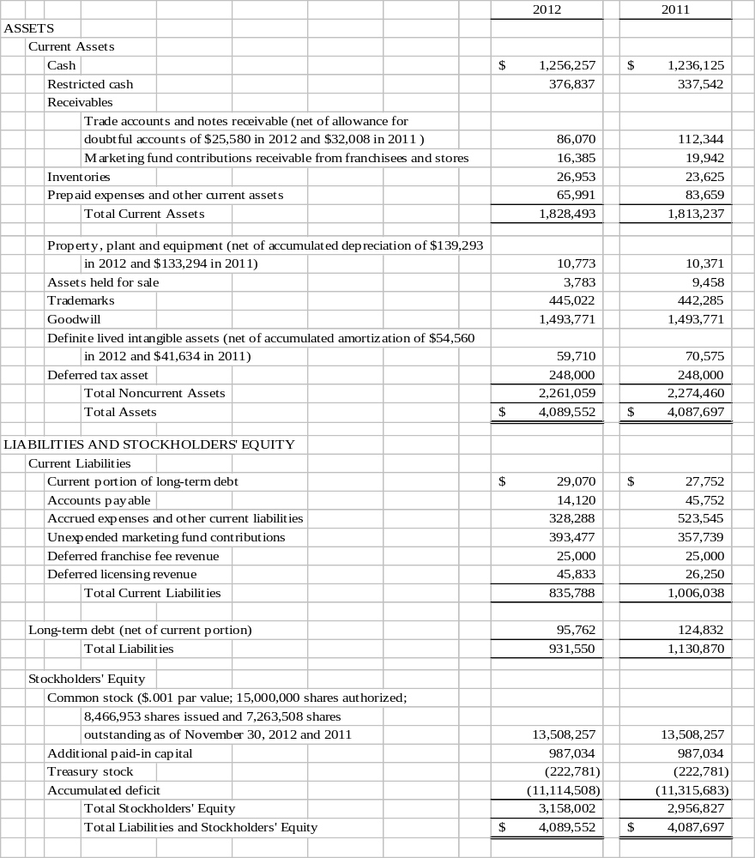See accompanying notes

BAB, Inc
Consolidated Statements of Income

Years Ended November 30, 2012 and 2011

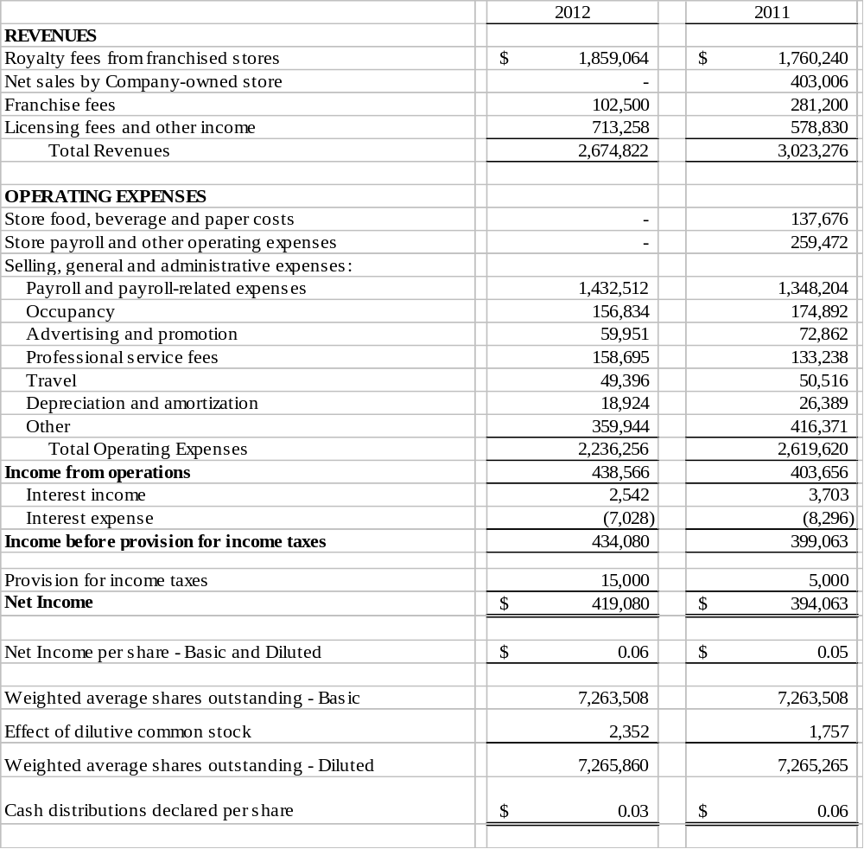

See accompanying notes

BAB, Inc
Consolidated Statements of Stockholders’ Equity
Years Ended November 30, 2012 and 2011

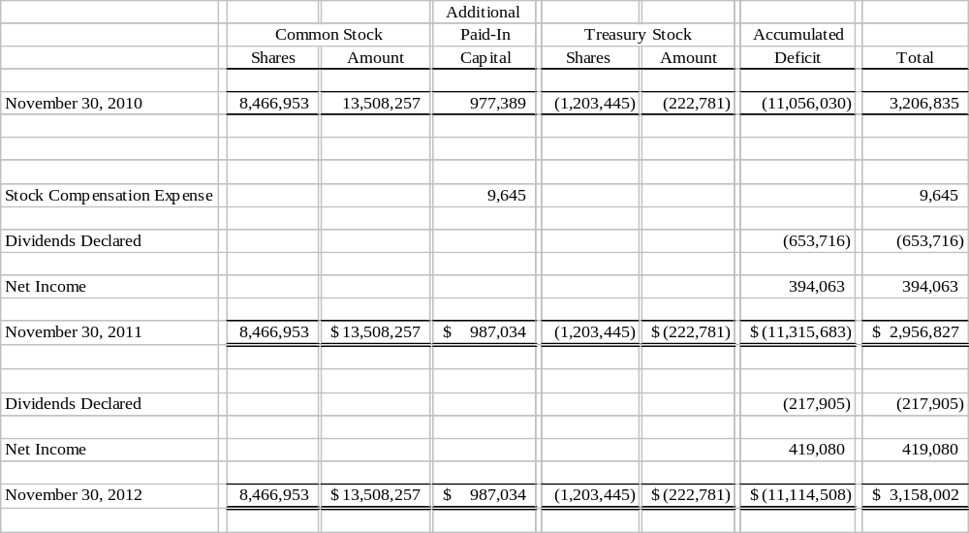

See accompanying notes

BAB, Inc

Consolidated Statements of Cash Flows
Years Ended November 30, 2012 and 2011

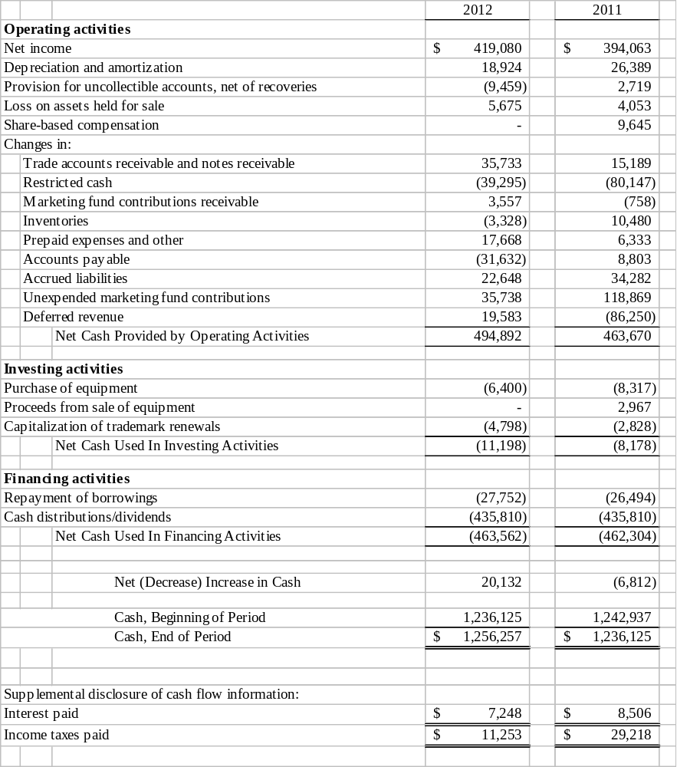

See accompanying notes

BAB, Inc
Notes to the Consolidated Financial Statements
November 30, 2012 and 2011

Note 1 - Nature of Operations

BAB, Inc (“the Company”) has two wholly owned subsidiaries: BAB Systems, Inc. (“Systems”) and BAB Operations, Inc. (“Operations”). Systems was incorporated on December 2, 1992, and was primarily established to franchise Big Apple Bagel (“BAB”) specialty bagel retail stores. My Favorite Muffin Too, Inc., a New Jersey corporation, was acquired on May 13, 1997 and is included as a part of Systems. Brewster’s Franchise Corporations (“Brewster’s”) was established on February 15, 1996. Brewster’s coffee is sold in BAB and My Favorite Muffin (“MFM”) locations as well as through license agreements. Operations was formed on August 30, 1995, primarily to operate Company-owned stores. The last Company-owned store was sold and became a franchise location November 30, 2011. The assets of Jacobs Bros. Bagels (“Jacobs Bros.”) were acquired on February 1, 1999. All branded wholesale business uses this trademark.

The Company was incorporated under the laws of the State of Delaware on July 12, 2000. The Company currently franchises and licenses bagel and muffin retail units under the BAB and MFM trade names. At November 30, 2012, the Company had 100 franchise units and 6 licensed units in operation in 24 states. The Company additionally derives income from the sale of its trademark bagels, muffins and coffee through nontraditional channels of distribution including under licensing agreements with Kohr Bros. Frozen Custard, Kaleidoscoops, Green Beans Coffee, Sodexo and through direct home delivery of specialty muffin gift baskets and coffee.
On May 7, 2012 the Company issued a press release announcing the launch of its new franchise concept, SweetDuet Frozen Yogurt & Gourmet Muffins (“SweetDuet”), which it is hoping to roll out in fiscal 2013. While BAB will be offering franchises in all 50 states, its initial development focus is targeted for the Midwest, specifically Illinois, Michigan, Wisconsin and Ohio. As part of its introductory development plan, BAB will be donating 10% of the initial franchise fee from its first 50 SweetDuet units to the Cystic Fibrosis Foundation, of which BAB is a corporate sponsor. SweetDuet, as its name implies, is a fusion concept, pairing self-serve frozen yogurt with BAB’s exclusive line of My Favorite Muffin gourmet muffins, broadening the shop’s offering and therefore differentiating itself from the numerous frozen yogurt outlets already populating the market. SweetDuet shops will also include BAB’s Brewster’s Coffee and a streamlined breakfast menu. The SweetDuet concept will be included as part of the Systems franchise operating and financial information.

Note 2 - Summary of Significant Accounting Policies

Principles of Consolidation

The consolidated financial statements include the accounts of the Company and its wholly owned subsidiaries. All intercompany accounts and transactions have been eliminated in consolidation.

Use of Estimates

The preparation of financial statements in conformity with accounting principles generally accepted in the United States of America requires management to make estimates and assumptions that affect the reported amounts of assets and liabilities and disclosure of contingent assets and liabilities at the date of the financial statements, and the reported amounts of revenues and expenses during the reporting period. Actual results could differ from those estimates.

BAB, Inc
Notes to the Consolidated Financial Statements
November 30, 2012 and 2011

Revenue Recognition

Royalty fees from franchised stores represent a 5% fee on net retail and wholesale sales of franchised units. Royalty revenues are recognized on an accrual basis using actual franchise receipts. Generally, franchisees report and remit royalties on a weekly basis. The majority of month-end receipts are recorded on an accrual basis based on actual numbers from reports received from franchisees shortly after the month-end. Estimates are utilized in certain instances where actual numbers have not been received and such estimates are based on the average of the last 10 weeks actual reported sales.

The Company recognizes franchise fee revenue on the store’s opening. Direct costs associated with the sale of franchises are deferred until the franchise fee revenue is recognized. These costs include site approval, construction approval, commissions, blueprints and training costs.

The Company earns a licensing fee from the sale of BAB branded products, which includes coffee, cream cheese, muffin mix and par baked bagels from a third-party commercial bakery to the franchised and licensed units.

Big Apple Bagels and My Favorite Muffin stores which are open, licensed units and unopened stores for which a Franchise Agreement has been executed, are as follows:

 |  | 2012 |  | 2011
Operating Units
Franchise Owned |  | 100 |  | 101
Licensed Units |  | 6 |  | 8
 |  | 106 |  | 109
Unopened stores with Franchise Agreements: |  | 1 |  | 1
Total operating units and units with Franchise Agreements |  | 107 |  | 110

License fees and other income primarily consist of license fees, Sign Shop and defaulted and terminated franchise contract revenues. Revenue is recorded on an accrual basis. Actual amounts are used to record the majority of license fees although at times it is necessary to use estimates. Revenues and expenses recorded for Sign Shop as well as defaulted and terminated franchise contract revenue are actual amounts.

Segments

Accounting standards have established annual reporting standards for an enterprise’s operating segments and related disclosures about its products, services, geographic areas and major customers. The Company’s operations were confined to a single reportable segment operating in the United States in fiscal 2012. The segment footnote for 2011 identifies a Company-owned store until November 30, 2011 at which point it was sold and became a franchise unit. This was deemed to be a separate segment.

Marketing Fund

The Company established a Marketing Fund in 1994. Franchise-operated units and any Company-owned stores are required to contribute a fixed percentage of their net retail sales to the Marketing Fund. Liabilities for unexpended funds received from franchisees are included as a separate line item in accrued expenses and Marketing Fund cash accounts are included in restricted funds in the accompanying Balance Sheet. The Marketing Fund also derives revenues from rebates paid by certain vendors on the sale of BAB licensed products to franchisees.

BAB, Inc
Notes to the Consolidated Financial Statements
November 30, 2012 and 2011

Note 2 - Summary of Significant Accounting Policies (Continued)

Cash

As of November 30, 2012 and 2011, the Marketing Fund cash balances, which are restricted, were $377,000 and $338,000, respectively.

As of November 30, 2012 the Federal Deposit Insurance Corporation (FDIC) insured up to $250,000 on interest bearing checking accounts and an unlimited amount on noninterest bearing checking accounts. The Company checking accounts are noninterest bearing accounts. Effective January 1, 2013 the FDIC maximum insurance on all interest and noninterest bearing checking accounts is $250,000. From January 1, 2013 the Company will exceed FDIC limits on some of its operating and marketing accounts.

Accounts and Notes Receivable

Receivables are carried at original invoice amount less estimates for doubtful accounts. Management determines the allowance for doubtful accounts by reviewing and identifying troubled accounts and by using historical collection experience. A receivable is considered to be past due if any portion of the receivable balance is outstanding 90 days past the due date. Receivables are written off when deemed uncollectible. Recoveries of receivables previously written off are recorded as income when received. Certain receivables have been converted to unsecured interest-bearing notes.

Inventories

Inventories are valued at the lower of cost or market under the first-in, first-out (FIFO) method.

Property, Plant and Equipment

Property and equipment and leasehold improvements are stated at cost less accumulated depreciation and amortization. Depreciation is calculated using the straight-line method over the estimated useful lives of the assets. Estimated useful lives are 3 to 7 years for property and equipment and 10 years, or term of lease, if less, for leasehold improvements. Maintenance and repairs are charged to expense as incurred. Expenditures that materially extend the useful lives of assets are capitalized.

Goodwill and Other Intangible Assets

Accounting Standard Codification (“ASC”) 350 (formerly SFAS No. 142) “Goodwill and Other Intangible Assets” requires that assets with indefinite lives no longer be amortized, but instead be subject to annual impairment tests. The Company follows this guidance.

The Company tests goodwill that is not subject to amortization for impairment annually or more frequently if events or circumstances indicate that impairment is possible. Goodwill was tested at the end of the first quarter, February 28, 2012 and it was found that the carrying value of goodwill and intangible assets were not impaired.

The impairment test performed February 28, 2012 was based on a discounted cash flow model using management’s business plan projected for expected cash flows. Based on the computation it was determined that no impairment was needed. An impairment test was performed at February 28, 2011 and based on the computation using discounted cash flows, it was also determined that no impairment occurred.

BAB, Inc
Notes to the Consolidated Financial Statements
November 30, 2012 and 2011

Note 2 - Summary of Significant Accounting Policies (Continued)

Goodwill and Other Intangible Assets (Continued)

The net book value of goodwill and intangible assets with indefinite and definite lives are as follows:

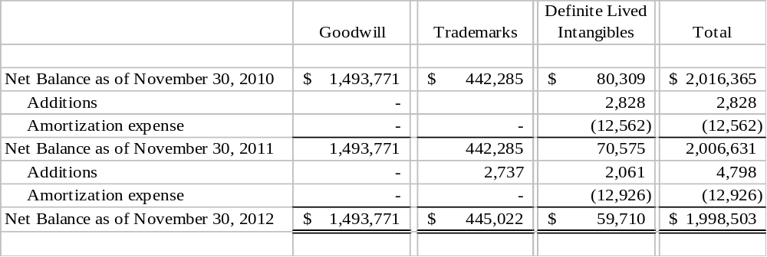

Definite lived intangible assets are being amortized over their useful lives. The estimated amortization expense for each of the next five fiscal years and thereafter is as follows:

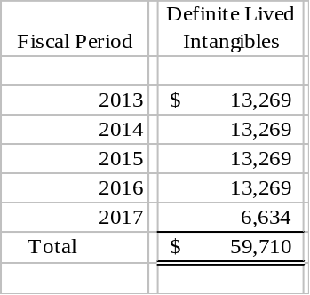

Reclassifications
The Company may reclassify certain items in the prior year financial statements for comparative purposes to conform with the presentation in the current year financial statements.

BAB, Inc
Notes to the Consolidated Financial Statements
November 30, 2012 and 2011

Note 2 - Summary of Significant Accounting Policies (Continued)

Advertising and Promotion Costs

The Company expenses advertising and promotion costs as incurred. Advertising and promotion expense was $60,000 and $73,000 in 2012 and 2011, respectively. Included in advertising expense was $60,000 and $51,000 in 2012 and 2011, respectively, related to the Company’s franchise operations. In 2011 there was $21,000 of advertising related to the Company-owned store.

Income Taxes

Deferred income taxes reflect the net tax effects of temporary differences between the carrying amounts of assets and liabilities for financial reporting purposes and the amounts used for income tax purposes. The benefits from net operating losses carried forward may be impaired or limited in certain circumstances. In addition, a valuation allowance can be provided for deferred tax assets when it is more likely than not that all or some portion of the deferred tax asset will not be realized.

The Company files a consolidated U.S. income tax return and tax returns in various state jurisdictions. Review of the Company’s possible tax uncertainties as of November 30, 2012 did not result in any positions requiring disclosure. Should the Company need to record interest and/or penalties related to uncertain tax positions or other tax authority assessments, it would classify such expenses as part of the income tax provision. The Company has not changed any of its tax policies or adopted any new tax positions during the fiscal year ended November 30, 2012 and believes it has filed appropriate tax returns in all jurisdictions for which it has nexus.

The Company’s income tax returns for the years ending November 30, 2009, 2010 and 2011 are subject to examination by the IRS and corresponding states, generally for three years after they are filed. (See Note 3.)

Earnings Per Share

The Company computes earnings per share (“EPS”) under ACS 260 “Earnings per Share.” Basic net earnings are divided by the weighted average number of common shares outstanding during the year to calculate basic net earnings per common share. Diluted net earnings per common share are calculated to give effect to the potential dilution that could occur if options or other contracts to issue common stock were exercised and resulted in the issuance of additional common shares.

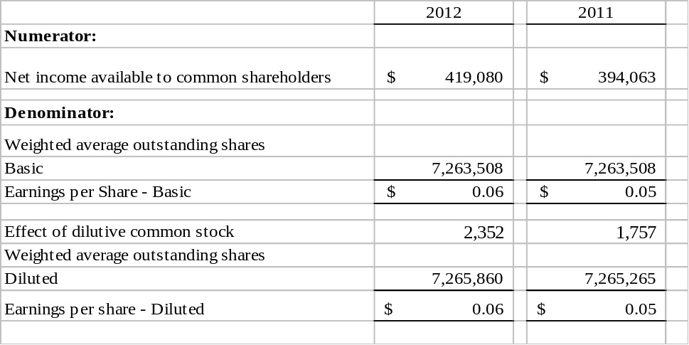
BAB, Inc
Notes to the Consolidated Financial Statements
November 30, 2012 and 2011

Note 2 - Summary of Significant Accounting Policies (Continued)

Earnings Per Share (Continued)

At November 30, 2012 there are 350,000 of unexercised options that are not included in the computation of dilutive EPS because their impact would be antidilutive due to the market price of the common stock being higher than the option prices. At November 30, 2011 there were 360,000 unexercised options that were not included in diluted EPS because their impact would be antidilutive due to the market price of the common stock being higher than the option prices.

Stock-Based Compensation

The Company recognizes compensation cost using a fair-value based method for all share-based payments granted after November 30, 2006, plus any awards granted to employees up through November 30, 2006 that remain unvested at that time. The Company had no recorded compensation expense arising from share-based payment arrangements in payroll-related expenses on the Consolidated Statement of Income for the Company’s stock option plan in 2012 and $10,000 for the year ended November 30, 2011.

Fair Value of Financial Instruments

The carrying amounts of financial instruments including cash, accounts receivable, notes receivable, accounts payable and short-term debt approximate their fair values because of the relatively short maturity of these instruments. The carrying value of long-term debt, including the current portion, approximate fair value based upon market prices for the same or similar instruments.

Recent Accounting Pronouncements

In June 2011, the Financial Accounting Standards Board (“FASB”) issued Accounting Standard Update (“ASU”) No. 2011-05, Comprehensive Income: Presentation of Comprehensive Income. The new guidance requires an entity to present the total of comprehensive income, the components of net income and the components of other comprehensive income either in a single continuous statement of comprehensive income or in two separate but consecutive statements. The guidance eliminates the option to present the components of other comprehensive income as part of the statement of equity. For public entities, the guidance is effective for fiscal years beginning after December 15, 2011. The Company believes that adoption of this guidance will not have any impact on the Company’s consolidated financial position, cash flows or results of operations.

In July 2012, the FASB issued ASU No. 2012-02, Intangibles – Goodwill and Other: Testing Indefinite-Lived Intangible Assets for Impairment. The amendment in the Update are intended to reduce cost and complexity by providing an entity the option to make a qualitative assessment about the likelihood that an indefinite-lived intangible asset is impaired to determine whether it should perform a quantitative impairment test. The update also enhances consistency of impairment testing guidance among long-lived asset categories by permitting entities to assess qualitative factors to determine whether it is necessary to calculate the asset’s fair value when testing for impairment, which is equivalent to the impairment testing requirements for other long-lived assets. The Update is effective for annual and interim impairment tests performed for fiscal years beginning after September 15, 2012. Early adoption is permitted, including for annual and interim impairment tests performed as of a date before July 27, 2012 (date of issuance of this Update). The Company adopted this guidance for its fiscal year ending November 30, 2012.

Management does not believe that there are any other recently issued and effective, or not yet effective, pronouncements as of November 30, 2012 that would have, or are expected to have, any significant effect on the Company’s consolidated financial position, cash flows or results of operations.

BAB, Inc
Notes to the Consolidated Financial Statements
November 30, 2012 and 2011

Note 3 – Income Taxes

The components of the Company’s current provision for income taxes are as follows:

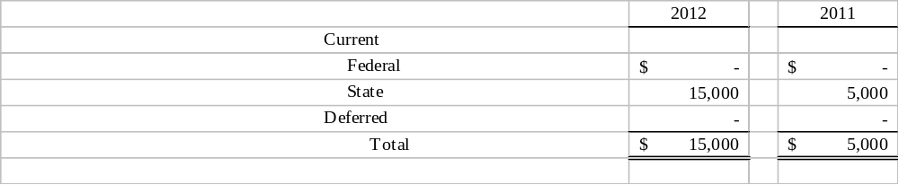

The effective tax rate used to compute income tax expense and deferred tax assets and liabilities is a federal rate of 34% and a state rate of 5.94%, net of the federal tax effect.

A reconciliation of the expected income tax expense to the recorded income tax expense is as follows:

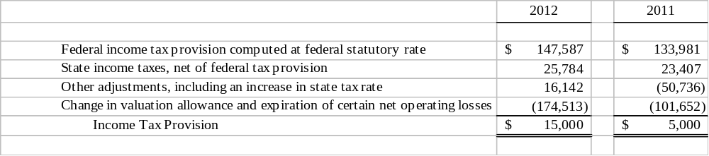

BAB, Inc
Notes to the Consolidated Financial Statements
November 30, 2012 and 2011

Note 3 – Income Taxes (Continued)

The components of the Company’s deferred tax assets and liabilities for federal and state income taxes consist of the following:

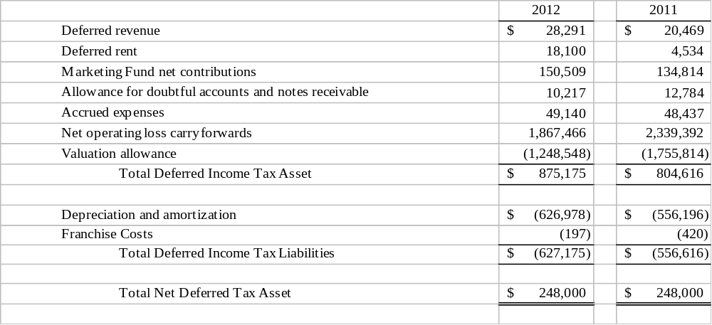

As of November 30, 2012 the Company has net operating loss carryforwards expiring between 2013 and 2029 for U.S. federal income tax purposes of approximately $4,676,000. The Company routinely reviews the future realization of tax assets based on projected future reversals of taxable temporary differences, available tax planning strategies and projected future taxable income. A valuation allowance has been established for $1,249,000 and $1,756,000 as of November 30, 2012 and 2011, respectively, for the deferred tax benefit related to those loss carryforwards and other deferred tax assets, that are more likely than not that the deferred tax asset will not be realized. The decrease in the valuation allowance of $507,000 in 2012 is a result of expiration of $339,000 of the 1997 net operating loss, the recognition of a portion of the net operating loss carryforwards and an increase in deferred tax liabilities relating primarily to depreciation and amortization.

BAB, Inc
Notes to the Consolidated Financial Statements
November 30, 2012 and 2011

Note 4 - Long-Term Debt

On September 6, 2002, the Company signed a note payable requiring annual installments of $35,000, including interest at a rate of 4.75% per annum, for a term of 15 years, in the original amount of $386,000. The Company purchased and retired 1,380,040 shares of BAB common stock from a former stockholder. The balance of this note payable was $125,000 and $153,000 as of November 30, 2012 and 2011, respectively.

As of November 30, 2012, annual maturities on long-term obligations due are as follows:

Year Ending November 30:
 | 2013 |  |  | $ 29,070
 | 2014 |  |  | 30,451
 | 2015 |  |  | 31,898
 | 2016 |  |  | 33,413
 | Total |  |  | $ 124,832

Note 5 - Stockholders’ Equity

The Board of Directors declared a cash distribution/dividend on February 27, May 25 and September 6, 2012 of $0.01 per share, paid April 9, July 6, and October 4, 2012, respectively.

The Board of Directors declared a $0.01 quarterly and $0.02 special cash distribution/dividend on December 6, 2010, paid January 5, 2011. The Board of Directors declared a $0.01 quarterly cash distribution/dividend on February 25, May 23 and September 6, 2011, paid April 15, July 5, and October 4, 2011, respectively. On November 28, 2011 a $0.01 quarterly cash distribution/dividend and a $0.02 special cash distribution/dividend was declared and paid January 4, 2012.

On December 3, 2012 the Board of Directors declared a $0.01 quarterly and a $0.04 special cash distribution/dividend payable on December 27, 2012.

Note 6 - Stock Options

In May 2001, the Company approved a Long-Term Incentive and Stock Option Plan (“Plan”). The Plan reserved 1,400,000 shares of common stock for grant, all of which have been granted as of November 30, 2009. The Plan terminated on May 25, 2011. The Plan permitted granting of awards to employees and non-employee Directors and agents of the Company in the form of stock appreciation rights, stock awards and stock options. The Plan was administered by a Committee of the Board of Directors appointed by the Board. The Plan gave broad powers to the Board and Committee to administer and interpret the Plan, including the authority to select the individuals to be granted options and rights and to prescribe the particular form and conditions of each option or right granted.

BAB, Inc
Notes to the Consolidated Financial Statements
November 30, 2012 and 2011

Note 6 - Stock Options (Continued)

Under the Plan, the exercise price of each option equals the market price of the Company’s stock on the date of grant. The options granted vary in vesting from immediate to a vesting period over five years. The options granted are exercisable within a 10 year period from the date of grant. All stock issued from the granted options must be held for one year from date of exercise. Options issued and outstanding expire on various dates through November 28, 2016. The range of exercise prices of options outstanding at November 30, 2012 are $0.46 to $1.38.

During fiscal 2012 and 2011 no options were granted or exercised. Activity under the Plan during the two years ended November 30 is as follows:

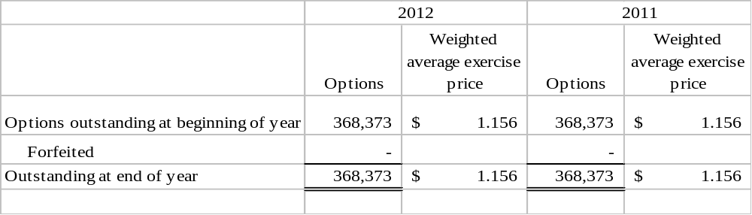

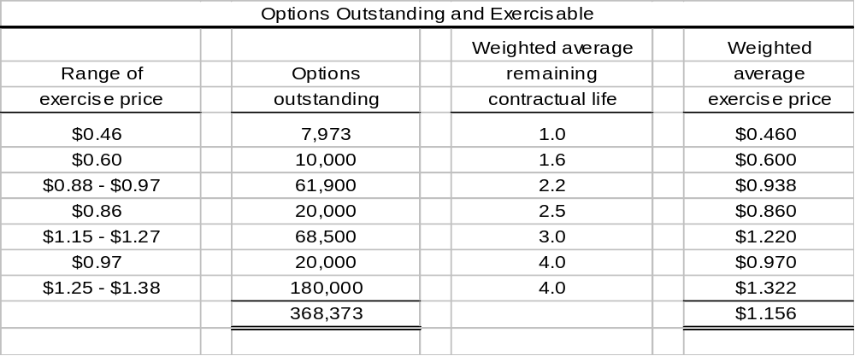

BAB, Inc
Notes to the Consolidated Financial Statements
November 30, 2012 and 2011

Note 6 - Stock Options (Continued)
The aggregate intrinsic value in the table below is before income taxes, based on the Company’s closing stock price of $0.63 as of the last business day of the period ended November 30, 2012. There were no options exercised in 2012 or 2011.
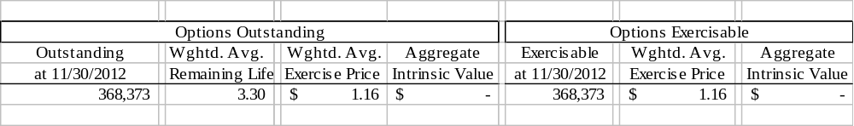
In fiscal 2012 the Company recorded no compensation cost arising from share-based payment arrangements in payroll-related expenses on the Consolidated Statement of Income for the Company’s stock option plan and $10,000 of expense for fiscal 2011. All options were fully vested in 2011 and there will be no further payroll-related expense from the stock options currently outstanding.

Note 7 - Commitments

The Company rents its Corporate office, and rented its former Company-owned store location under leases which require it to pay base rent, real estate taxes, insurance and general repairs and maintenance. The Corporate office lease is through September 30, 2018. The former Company-owned store lease expired December 31, 2011 and will not be renewed. Rent expense for the years ended November 30, 2012 and 2011 was $153,000 and $224,000, respectively. Monthly rent is recorded on a straight-line basis over the term of the lease with a deferred rent liability being recognized. As of November 30, 2012, future minimum annual rental commitments under the Corporate lease are as follows:

Year Ending November 30:
2013 |  | $ 110,434
2014 |  | 113,709
2015 |  | 116,983
2016 |  | 120,257
2017 |  | 134,843
Thereafter |  | 115,197
Total |  | $ 711,423

Note 8 – Employee Benefit Plan

The Company maintains a qualified 401(k) plan which allows eligible participants to make pretax contributions. Company contributions are discretionary. The Company did not make a contribution in 2012 or 2011.

BAB, Inc
Notes to the Consolidated Financial Statements
November 30, 2012 and 2011

Note 9 - Segment Information

Segment information has been reclassified to reflect licensing fees revenue, goodwill and certain definite lived assets and the amortization expense related to these intangibles in Systems, so as to reflect a truer segment income stream and asset relationship, as the business is focused on the franchise division.

The following table presents segment information for the years ended November 30, 2012 and 2011: There were no sales to any individual customer during either year that represented 10% or more of net sales.

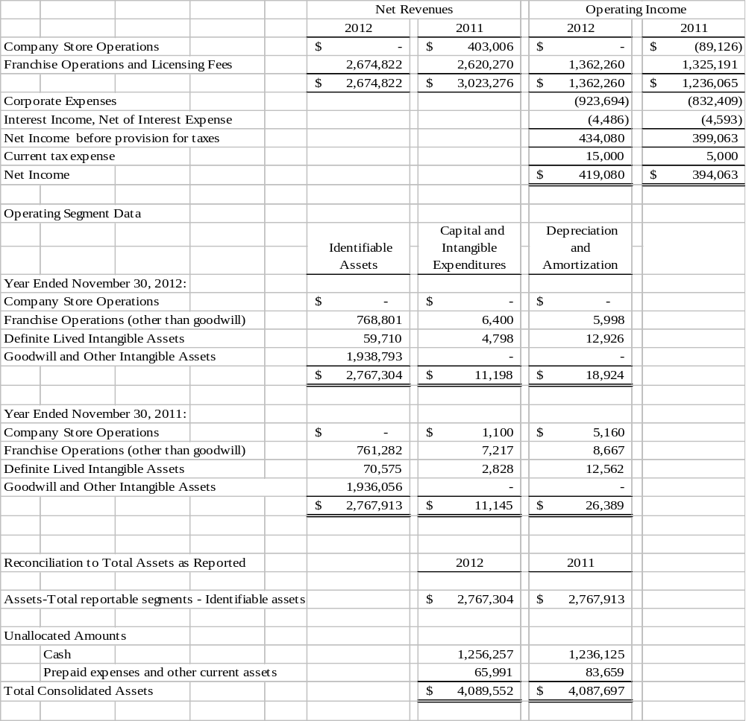

Item 9. changes in and disagreements with accountants on accounting and financial disclosure

In connection with the audits of the Company’s consolidated financial statements for each of the fiscal years ended November 30, 2012 and 2011, and through the date of this Current Report, there were: (1) no disagreements between the Company and Sassetti LLC on any matters of accounting principles or practices, financial statement disclosure or auditing scope or procedures.

Item 9A. Controls and Procedures

Disclosure Controls and Procedures

BAB, Inc.’s Chief Executive Officer and Chief Financial Officer have evaluated the Company’s disclosure controls and procedures, as defined in Item 307 of Regulation S-K of the Securities Exchange Act of 1934, as of the end of the period covered by this report, and they have concluded that these controls and procedures were effective (i) to ensure that information required to be disclosed by us in the reports that we file or submit under the Exchange Act is recorded, processed, summarized and reported within the time periods specified in the SEC’s rules and forms and (ii) to ensure that information required to be disclosed by us in the reports that we submit under the Exchange Act is accumulated and communicated to our management, including our executive and financial officers, or persons performing similar functions, as appropriate, to allow timely decisions regarding required disclosure.

Internal Control Over Financial Reporting

Management’s Annual Report on Internal Control over Financial Reporting
.
Our management is responsible for establishing and maintaining adequate internal control over financial reporting. Internal control over financial reporting is a process designed by, or under the supervision of, the Chief Executive Officer and the Chief Financial Officer, management and other personnel, to provide reasonable assurance regarding the reliability of financial reporting and the preparation of financial statements for external purposes in accordance with generally accepted accounting principles.

Our evaluation of internal control over financial reporting includes using the COSO framework, an integrated framework for the evaluation of internal controls issued by the Committee of Sponsoring Organizations of the Treadway Commission, to identify the risks and control objectives related to the evaluation of our control environment.

Based on our evaluation under the framework described above, our management, including the Chief Executive Officer and Chief Financial Officer, concluded that the Company’s internal controls and procedures were effective over financial reporting as of November 30, 2012.
This annual report does not include an attestation report of the Company’s registered public accounting firm regarding internal control over financial reporting. Management’s report was not subject to attestation requirements by the Company’s registered public accounting firm pursuant to rules of the Securities and Exchange Commission that permits the Company to provide only management’s report in this annual report.
Changes in Internal Control Over Financial Reporting
There were no changes in our internal controls or in other factors that could materially affect these controls over financial reporting during the last fiscal quarter. We have not identified any significant deficiencies or material weaknesses in our internal controls, and therefore there were no corrective actions taken.

Item 9B. OTHER INFORMATION
None.
PART III

ITEM 10. DIRECTORS, EXECUTIVE OFFICERS AND CORPORATE GOVERNANCE

Section 16(a) of the Securities Exchange Act of 1934 requires the Company's executive officers and directors, and persons who beneficially own more than ten percent of the Company's Common Stock, to file initial reports of ownership and reports of changes in ownership with the Securities and Exchange Commission (the "SEC"). Executive officers, directors and greater than ten percent beneficial owners are required by the SEC to furnish the Company with copies of all Section 16(a) forms they file.

Based upon a review of the copies of such forms furnished to the Company, the Company believes that all Section 16(a) filing requirements applicable to its executive officers and directors were met during the year ended November 30, 2012.

BAB, Inc. (the Company) has a formally established Code of Ethics, pursuant to Section 406 of the Sarbanes-Oxley Act. In order to view the Code of Ethics in its entirety, see the BAB, Inc. Annual Report, Part III, Item 9, dated November 30, 2007 and filed with the Securities and Exchange Commission on February 28, 2008.

ITEM 11. EXECUTIVE COMPENSATION

The following table sets forth the cash compensation by executive officers that received annual salary and bonus compensation of more than $100,000 during years 2012 and 2011 (the "Named Executive Officers"). The Company has no employment agreements with any of its executive officers.

Summary Compensation Table

Name and Principal  Position | Year | Salary  ($) | Bonus  ($) | Stock  Awards  ($) | Options Awards ($) | Nonequity  Incentive Plan  Compensation  (S) | Non-qualified  deferred  Compensation  earnings  (S) | All other  compensation  ($) | Total  ($)
Michael W. Evans  President and CEO | 2012 | 249,831 | 50,916 | - | - | - | - | - | 300,747
Michael W. Evans  President and CEO | 2011 | 249,831 | 40,184 | - | - | - | - | - | 290,015
Michael K. Murtaugh  Vice President and General Counsel | 2012 | 187,380 | 38,188 | - | - | - | - | - | 225,568
Michael K. Murtaugh  Vice President and General Counsel | 2011 | 187,380 | 30,139 | - | - | - | - | - | 217,519
Jeffrey M Gorden  Chief Financial Officer | 2012 | 133,686 | 7,500 | - | - | - | - | - | 141,186
Jeffrey M Gorden  Chief Financial Officer | 2011 | 133,686 | 5,000 | - | - | - | - | - | 138,686

The following tables set forth any stock or stock options awarded to executive officers that that are exercisable and not yet exercised or unexercisable as of November 30, 2012:

OUTSTANDING EQUITY AWARDS AT FISCAL YEAR-END

Name | Number of  securities underlying unexercised options  (#)  Exercisable | Number of  securities underlying unexercised options  (#)  Unexercisable | Equity incentive plan awards: number of securities underlying unexercised unearned options  (#) | Option  exercise  price  ($) | Option expiration date
Michael W. Evans  President and CEO | 20,000 | - | - | .97 | 2015
Michael W. Evans  President and CEO | 20,000 | - | - | 1.27 | 2016
Michael W. Evans  President and CEO | 50,000 | - | - | 1.38 | 2016
Michael K. Murtaugh  Vice President and General Counsel | 20,000 | - | - | .97 | 2015
Michael K. Murtaugh  Vice President and General Counsel | 20,000 | - | - | 1.27 | 2016
Michael K. Murtaugh  Vice President and General Counsel | 50,000 | - | - | 1.38 | 2016
Jeffrey M Gorden  Chief Financial Officer | 1,833 | - | - | .46 | 2014
Jeffrey M Gorden  Chief Financial Officer | 6,000 | - | - | .88 | 2015
Jeffrey M Gorden  Chief Financial Officer | 5,000 | - | - | 1.15 | 2015
Jeffrey M Gorden  Chief Financial Officer | 25,000 | - | - | 1.25 | 2016

OUTSTANDING EQUITY AWARDS AT FISCAL YEAR-END
(Continued)

Name | Number of shares or units of stock that have not vested  (#) | Market value of shares or units of stock that have not vested  ($) | Equity incentive plan awards: number of unearned shares, units or other rights that have not vested  (#) | Equity incentive plan awards: market or payout value of unearned shares, units or other rights that have not vested  ($)
Michael W. Evans  President and CEO | - | - | - | -
Michael W. Evans  President and CEO | - | - | - | -
Michael K. Murtaugh  Vice President and General Counsel | - | - | - | -
Michael K. Murtaugh  Vice President and General Counsel | - | - | - | -
Jeffrey M Gorden  Chief Financial Officer | - | - | - | -
Jeffrey M Gorden  Chief Financial Officer | - | - | - | -

The following table sets forth any compensation paid to directors during fiscal year ended November 30, 2012:

DIRECTOR COMPENSATION
Compensation for fiscal year ended November 30, 2012

Name | Fees earned or paid in cash  ($) | Stock awards  ($) | Option awards  ($) | Non-equity incentive plan compensation  ($) | Non-qualifies deferred compensation earnings  ($) | All other compensation  ($) | Total  ($)
Steven Feldman | 1,900 | - | - | - | - | - | 1,900
James Lentz | 1,900 | - | - | - | - | - | 1,900

Indemnification of Directors and Officers

The Company's Certificate of Incorporation limits personal liability for breach of fiduciary duty by its directors to the fullest extent permitted by the Delaware General Corporation Law (the "Delaware Law"). Such Certificate eliminates the personal liability of directors to the Company and its shareholders for damages occasioned by breach of fiduciary duty, except for liability based on breach of the director's duty of loyalty to the Company, liability for acts or omissions not made in good faith, liability for acts or omissions involving intentional misconduct, liability based on payments or improper dividends, liability based on violation of state securities laws, and liability for acts occurring prior to the date such provision was added. Any amendment to or repeal of such provisions in the Company's Certificate of Incorporation shall not adversely affect any right or protection of a director of the Company for with respect to any acts or omissions of such director occurring prior to such amendment or repeal.

In addition to the Delaware Law, the Company's Bylaws provide that officers and directors of the Company have the right to indemnification from the Company for liability arising out of certain actions to the fullest extent permissible by law. Insofar as indemnification for liabilities arising under the Securities Act of 1933 (the "Act") may be permitted to directors, officers or persons controlling the Company pursuant to such indemnification provisions, the Company has been advised that in the opinion of the Securities and Exchange Commission such indemnification is against public policy as expressed in the Act and is therefore unenforceable.

ITEM 12. SECURITY OWNERSHIP OF CERTAIN BENEFICIAL OWNERS AND MANAGEMENT AND RELATED STOCKHOLDER MATTERS

The following table sets forth as of February 15, 2012 the record and beneficial ownership of Common Stock held by (i) each person who is known to the Company to be the beneficial owner of more than 5% of the Common Stock of the Company; (ii) each current director; (iii) each "named executive officer" (as defined in Regulation S-B, Item 402 under the Securities Act of 1933); and (iv) all executive officers and directors of the Company as a group. Securities reported as "beneficially owned" include those for which the named persons may exercise voting power or investment power, alone or with others. Voting power and investment power are not shared with others unless so stated. The number and percent of shares of Common Stock of the Company beneficially owned by each such person as of February 15, 2012 includes the number of shares which such person has the right to acquire within sixty (60) days after such date.

Name and Address |  | Shares | Percentage
Michael W. Evans  500 Lake Cook Road, Suite 475  Deerfield, IL 60015 |  | 1,584,690 ⁽¹⁾⁽²⁾⁽³⁾ | 21.04
Michael K. Murtaugh  500 Lake Cook Road, Suite 475  Deerfield, IL 60015 |  | 1,058,054 ⁽¹⁾ | 14.05
Jeffrey M. Gorden  500 Lake Cook Road, Suite 475  Deerfield, IL 60015 |  | 42,845 ⁽⁴⁾ | .57
Steven G. Feldman  750 Estate Drive, Suite 104  Deerfield, IL 60015 |  | 40,000 ⁽⁵⁾ | .53
James A. Lentz  1415 College Lane South  Wheaton, IL 60189 |  | 34,932 ⁽⁶⁾ | .46
All executive officers and directors as a group (5 persons) |  | 2,755,521 ⁽¹⁾⁽²⁾⁽³⁾⁽⁴⁾⁽⁵⁾⁽⁶⁾ | 36.59

(1) Includes 90,000 stock options fully exercisable as of 2/15/13.
(2) Includes 3,500 shares inherited by spouse.
(3) Includes 62,222 shares held by children.
(4) Includes 37,833 stock options fully exercisable as of 2/15/13.
(5) Includes 30,000 stock options fully exercisable as of 2/15/13.
(6) Includes 20,000 stock options fully exercisable as of 2/15/13.

ITEM 13. CERTAIN RELATIONSHIPS AND RELATED TRANSACTIONS AND DIRECTOR INDEPENDENCE

There are no transactions between the Company and related parties, including officers and directors of the Company. It is the Company's policy that it will not enter into any transactions with officers, directors or beneficial owners of more than 5% of the Company's Common Stock, or any entity controlled by or under common control with any such person, on terms less favorable to the Company than could be obtained from unaffiliated third parties and all such transactions require the consent of the majority of disinterested members of the Board of Directors.

ITEM 14. PRINCIPAL ACCOUNTANT FEES AND SERVICES

The Board of Directors upon recommendation of the Audit Committee, appointed the firm Sassetti LLC, certified public accountants, for 2012 audit and tax services.

The audit reports of Sassetti LLC on the consolidated financial statements of BAB, Inc. and Subsidiaries as of and for the years ended November 30, 2012 and 2011 did not contain an adverse opinion or a disclaimer of opinion, and was not qualified or modified as to uncertainty, audit scope or accounting principles.

Audit fees relate to audit work performed on the financial statements as well as work that generally only the independent auditor can reasonably be expected to provide, including discussions surrounding the proper application of financial accounting and/or reporting standards and reviews of the financial statements included in quarterly reports filed on Form 10-Q. Fees for audit services provided by Sassetti LLC in fiscal 2012 and 2011 were $63,000 and $62,000, respectively.

Tax compliance services provided by Sassetti LLC were $13,000 and $12,000 for 2012 and 2011, respectively.

During the years ended November 30, 2012 and 2011, Sassetti LLC did not perform any other services for the Company.

Preapproval of Policies and Procedures by Audit Committee

The accountants provide a quote for services to the Audit Committee before work begins for the fiscal year. After discussion, the Audit Committee then makes a recommendation to the Board of Directors on whether to accept the proposal.

Percentage of Services Approved by Audit Committee

All services were approved by the Audit Committee.

PART IV

ITEM 15. EXHIBITS AND FINANCIAL STATEMENT SCHEDULES.

(a) Documents filed as part of this report:
- Financial Statements
Consolidated Balance Sheets as at November 30, 2012 and 2011 and the Consolidated Statements of Income, Shareholders’ Equity and Cash Flows for the years ended November 30, 2012 and 2011 are reported on by Sassetti LLC. These statements are prepared in accordance with United States GAAP.
- Financial Statement Schedules - none
.

(b) INDEX TO EXHIBITS
The following Exhibits are filed herewith:
INDEX NUMBER | DESCRIPTION
3.1 | Articles of Incorporation (See Form 10-KSB for year ended November 30, 2006)
3.2 | Bylaws of the Company (See Form 10-KSB for year ended November 30, 2006)
21.1 | List of Subsidiaries of the Company
31.1, 31.2 | Section 302 of the Sarbanes-Oxley Act of 2002
32.1, 32.2 | Section 906 of the Sarbanes-Oxley Act of 2002

SIGNATURES

Pursuant to the requirements of Section 13 or 15(d) of the Securities Exchange Act of 1934, the registrant has duly caused this report to be signed on its behalf by the undersigned, thereunto duly authorized.
BAB, INC.

By /s/ Michael W. Evans
Michael W. Evans, Chief Executive Officer and President (Principal Executive Officer)
Dated: February 22, 2013

Pursuant to the requirements of the Securities Exchange Act of 1934, this report on Form 10-K has been signed below by the following persons on behalf of the Company and in the capacities and on the dates indicated.

Dated: February 22, 2013
By /s/ Michael W. Evans
Michael W. Evans, Chief Executive Officer and President (Principal Executive Officer)
Dated: February 22, 2013
By /s/ Michael K. Murtaugh
Michael K. Murtaugh, Director and Vice President/General Counsel and Secretary

Dated: February 22, 2013
By /s/ Jeffrey M. Gorden
Jeffrey M. Gorden, Chief Financial Officer and Treasurer (Principal Financial and Accounting Officer)
Dated: February 22, 2013
By /s/ Steven G. Feldman
Steven G. Feldman, Director
Dated: February 22, 2013
By /s/ James A. Lentz
James A. Lentz, Director

EXHIBIT 3.1 - Certificate of Incorporation

See Form 10-KSB for year ended November 30, 2006

EXHIBIT 3.2 - Bylaws of BAB, Inc.

See Form 10-KSB for year ended November 30, 2006

EXHIBIT 21.1 – List of Subsidiaries of the Company
BAB Systems, Inc., an Illinois corporation
BAB Operations, Inc., an Illinois corporation

Exhibit 31.1
CERTIFICATION OF THE CHIEF EXECUTIVE OFFICER PURSUANT TO RULE 13A-14 (a) OR RULE 15d-14 (a) OF THE SECURITIES EXCHANGE ACT OF 1934.
I, Michael W. Evans, certify that:
- I have reviewed this annual report on Form 10-K of BAB, Inc.
- Based on my knowledge, this report does not contain any untrue statement of a material fact or omit to state a material fact necessary to make the statements made, in light of the circumstances under which such statements were made, not misleading with respect to the period covered by this report;
- Based on my knowledge, the financial statements, and other financial information included in this report, fairly present in all material respects the financial condition, results of operations and cash flows of the registrant as of, and for, the periods presented in this report;
- The registrant’s other certifying officer(s) and I are responsible for establishing and maintaining disclosure controls and procedures (as defined in Exchange Act Rules 13a -15(e) and 15d -15(e)) and internal control over financial reporting (as defined in Exchange Act Rules 13a – 15(f) and 15d -15(f)) for the registrant and have:
  - Designed such disclosure controls and procedures, or caused such disclosure controls and procedures to be designed under our supervision, to ensure that material information relating to the registrant, including its consolidated subsidiaries, is made known to us by others within those entities, particularly during the period in which this report is being prepared;
  - Designed such internal control over financial reporting, or caused such internal control over financial reporting to be designed under our supervision, to provide reasonable assurance regarding the reliability of financial reporting and the preparation of financial statements for external purposes in accordance with generally accepted accounting principles;
  - Evaluated the effectiveness of the registrant’s disclosure controls and procedures and presented in this report our conclusions about the effectiveness of the disclosure controls and procedures, as of the end of the period covered by this report based on such evaluation; and
  - Disclosed in this report any change in the registrant’s internal control over financial reporting that occurred during the registrant’s most recent fiscal quarter (the registrant’s fourth fiscal quarter in the case of an annual report) that has materially affected, or is reasonably likely to materially affect, the registrant’s internal control over financial reporting; and
- The registrant’s other certifying officer(s) and I have disclosed, based on our most recent evaluation of internal control over financial reporting, to the registrant’s auditors and the audit committee of the registrant’s board of directors (or persons performing the equivalent functions):
  - All significant deficiencies and material weaknesses in the design or operation of internal control over financial reporting which are reasonably likely to adversely affect the registrant’s ability to record, process, summarize and report financial information; and
  - Any fraud, whether or not material, that involves management or other employees who have a significant role in the registrant’s internal control over financial reporting.

Date: February 22, 2013 By / s/ Michael W. Evans
Michael W. Evans, Chief Executive Officer

Exhibit 31.2
CERTIFICATION OF CHIEF FINANCIAL OFFICER PURSUANT TO RULE 13A-14 (a) OR RULE 15d-14 (a) OF THE SECURITIES EXCHANGE ACT OF 1934.
I, Jeffrey M. Gorden, certify that:
- I have reviewed this annual report on Form 10-K of BAB, Inc.
- Based on my knowledge, this report does not contain any untrue statement of a material fact or omit to state a material fact necessary to make the statements made, in light of the circumstances under which such statements were made, not misleading with respect to the period covered by this report;
- Based on my knowledge, the financial statements, and other financial information included in this report, fairly present in all material respects the financial condition, results of operations and cash flows of the registrant as of, and for, the periods presented in this report;
- The registrant’s other certifying officer(s) and I are responsible for establishing and maintaining disclosure controls and procedures (as defined in Exchange Act Rules 13a -15(e) and 15d -15(e)) and internal control over financial reporting (as defined in Exchange Act Rules 13a – 15(f) and 15d -15(f)) for the registrant and have:
  - Designed such disclosure controls and procedures, or caused such disclosure controls and procedures to be designed under our supervision, to ensure that material information relating to the registrant, including its consolidated subsidiaries, is made known to us by others within those entities, particularly during the period in which this report is being prepared;
  - Designed such internal control over financial reporting, or caused such internal control over financial reporting to be designed under our supervision, to provide reasonable assurance regarding the reliability of financial reporting and the preparation of financial statements for external purposes in accordance with generally accepted accounting principles;
  - Evaluated the effectiveness of the registrant’s disclosure controls and procedures and presented in this report our conclusions about the effectiveness of the disclosure controls and procedures, as of the end of the period covered by this report based on such evaluation; and
  - Disclosed in this report any change in the registrant’s internal control over financial reporting that occurred during the registrant’s most recent fiscal quarter (the registrant’s fourth fiscal quarter in the case of an annual report) that has materially affected, or is reasonably likely to materially affect, the registrant’s internal control over financial reporting; and
- The registrant’s other certifying officer(s) and I have disclosed, based on our most recent evaluation of internal control over financial reporting, to the registrant’s auditors and the audit committee of the registrant’s board of directors (or persons performing the equivalent functions):
  - All significant deficiencies and material weaknesses in the design or operation of internal control over financial reporting which are reasonably likely to adversely affect the registrant’s ability to record, process, summarize and report financial information; and
  - Any fraud, whether or not material, that involves management or other employees who have a significant role in the registrant’s internal control over financial reporting.

Date: February 22, 2013 By: /s/ Jeffrey M. Gorden
Jeffrey M. Gorden, Chief Financial Officer

Exhibit 32.1
BAB, Inc.
CERTIFICATION PURSUANT TO 18 U.S.C. SECTION 1350
AS ADOPTED PURSUANT TO SECTION 906 OF THE SARBANES-OXLEY ACT OF 2002
In connection with the BAB, Inc. (the "Company") Annual Report on Form 10-K for the period ended November 30, 2012, as filed with the Securities and Exchange Commission on the date hereof (the "Report"), I, Michael W. Evans, Chief Executive Officer of the Company, certify pursuant to 18 U.S.C. Section 1350, as adopted pursuant to Section 906 of the Sarbanes-Oxley Act of 2002, that, to the best of my knowledge:
- The Report fully complies with the requirements of section 13(a) or 15(d) of the Securities and Exchange Act of 1934, as amended; and
- The information contained in the Report fairly presents, in all material respects, the financial condition, results of operations, and cash flows of the Company.
Date: February 22, 2013 By: /s/ Michael W. Evans
Michael W. Evans, Chief Executive Officer

Exhibit 32.2

BAB, Inc.
CERTIFICATION PURSUANT TO 18 U.S.C. SECTION 1350
AS ADOPTED PURSUANT TO SECTION 906 OF THE SARBANES-OXLEY ACT OF 2002
In connection with the BAB, Inc. (the "Company") Annual Report on Form 10-K for the period ended November 30, 2012, as filed with the Securities and Exchange Commission on the date hereof (the "Report"), I, Jeffrey M. Gorden, Chief Financial Officer of the Company, certify pursuant to 18 U.S.C. Section 1350, as adopted pursuant to Section 906 of the Sarbanes-Oxley Act of 2002, that, to the best of my knowledge:
- The Report fully complies with the requirements of section 13(a) or 15(d) of the Securities and Exchange Act of 1934, as amended; and
- The information contained in the Report fairly presents, in all material respects, the financial condition, results of operations, and cash flows of the Company.

Date: February 22, 2013 By: /s/ Jeffrey M. Gorden
Jeffrey M. Gorden, Chief Financial Officer

