FORM 10-Q
U.S. SECURITIES AND EXCHANGE COMMISSION
Washington, D.C. 20549
(Mark One)
[X] | QUARTERLY REPORT PURSUANT TO SECTION 13 OR 15(d) OF THE SECURITIES EXCHANGE ACT OF 1934  For the quarterly period ended May 31, 2014
[ ] | TRANSITION REPORT UNDER SECTION 13 OR 15(d) OF THE SECURITIES EXCHANGE ACT OF 1934  For the transition period from ________________ to _________________  Commission file number: 0-31555
BAB, Inc.
(Name of small business issuer in its charter)

Delaware | 36-4389547
(State or other jurisdiction of incorporation or organization) | (I.R.S. Employer Identification No.)
500 Lake Cook Road, Suite 475, Deerfield, Illinois 60015
(Address of principal executive offices) (Zip Code)
Issuer's telephone number (847) 948-7520
Indicate by checkmark whether the registrant (1) filed all reports required to be filed by Section 13 or 15(d) of the Exchange Act during the preceding 12 months (or for such shorter period that the registrant was required to file such reports), and (2) has been subject to such filing requirements for the past 90 days. Yes X No
Indicate by check mark whether the registrant has submitted electronically and posted on its corporate Web site, if any, every Interactive Data File required to be submitted and posted pursuant to Rule 405 of Regulation S-T (§232.405 of this chapter) during the preceding 12 months (or for such shorter period that the registrant was required to submit and post such files). Yes X No
Indicate by checkmark whether the registrant is a large accelerated filer, accelerated filer, a non-accelerated filer, or a smaller reporting company. Large accelerated filer Accelerated filer Non-accelerated filer (Do not check if a smaller reporting company) Smaller reporting company X
Indicate by checkmark whether the registrant is a shell company. Yes No X
As of July 10, 2014 BAB, Inc. had: 7,263,508 shares of Common Stock outstanding.

TABLE OF CONTENTS
PART I | FINANCIAL INFORMATION
Item 1. | Financial Statements
Item 2 | Management's Discussion and Analysis of Financial Condition and Results of Operation
Item 3 | Quantitative and Qualitative Disclosures About Market Risk
Item 4 | Controls and Procedures
PART II | OTHER INFORMATION
Item 1. | Legal Proceedings
Item 2 | Unregistered Sales of Equity Securities and Use of Proceeds
Item 3 | Defaults Upon Senior Securities
Item 4 | Mine Safety Disclosures
Item 5 | Other Information
Item 6 | Exhibits
SIGNATURE

PART I
ITEM 1. | FINANCIAL STATEMENTS
BAB, Inc.
Consolidated Balance Sheets
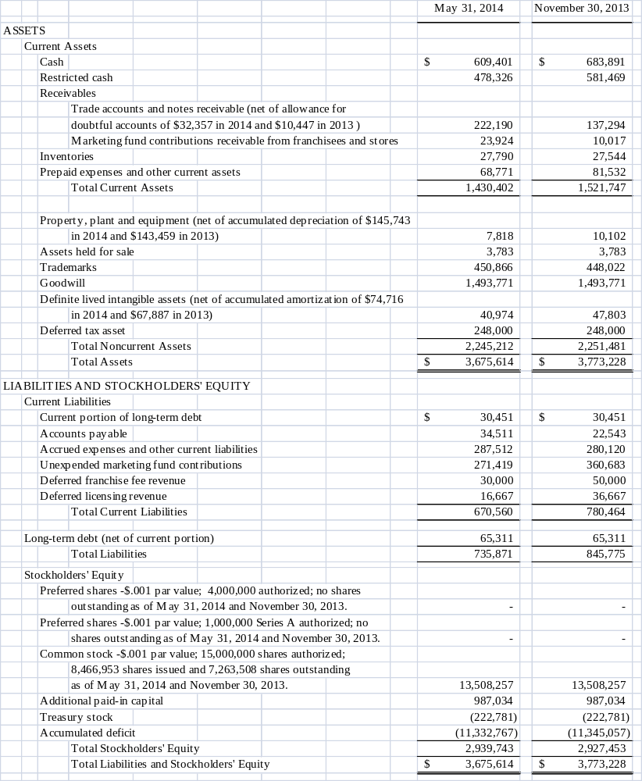
SEE ACCOMPANYING NOTES

BAB, Inc.
Consolidated Statements of Income
For the Quarters Ended May 31, 2014 and 2013
(Unaudited)

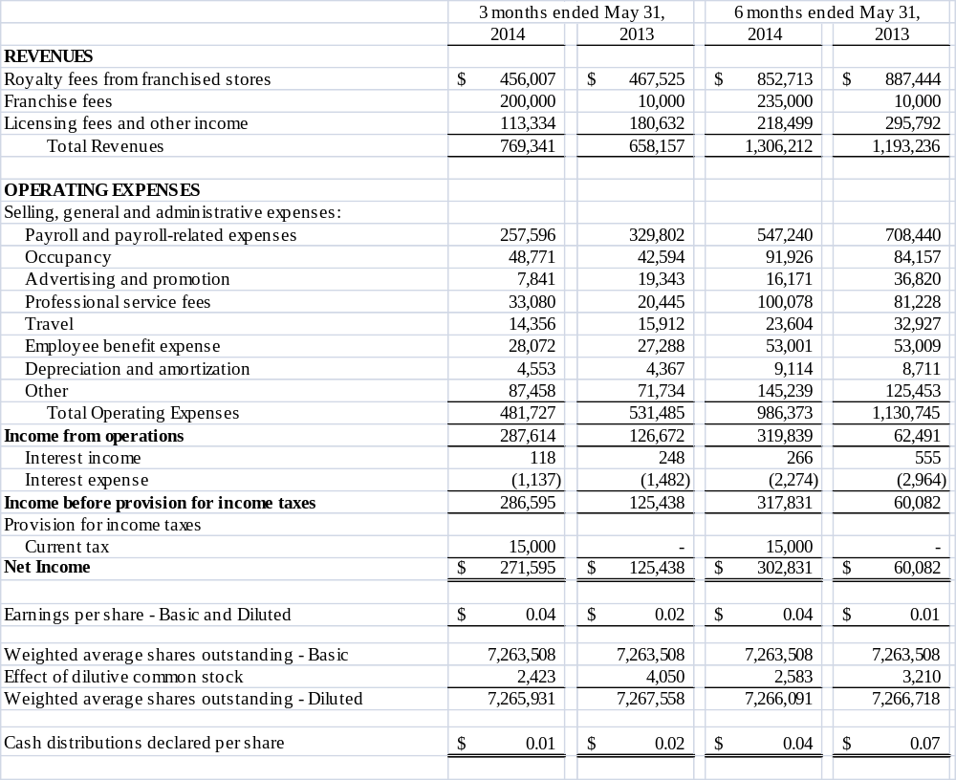

SEE ACCOMPANYING NOTES

BAB, Inc.
Consolidated Statements of Cash Flows
For the Quarters Ended May 31, 2014 and 2013
(Unaudited)

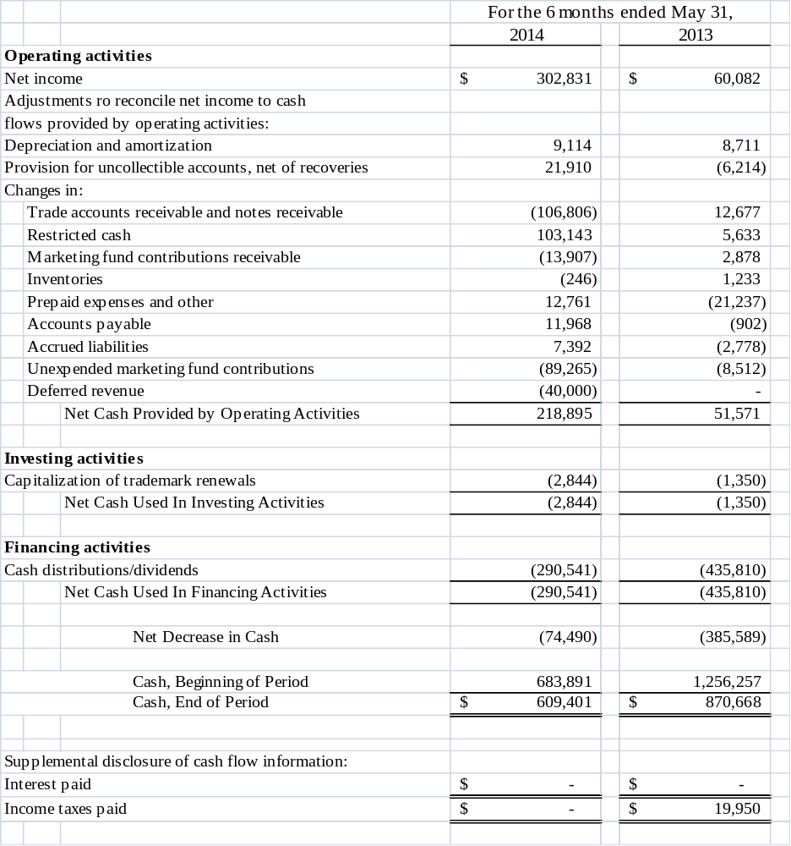

SEE ACCOMPANYING NOTES

BAB, Inc.
Notes to Unaudited Consolidated Financial Statements
For the Quarters Ended May 31, 2014 and 2013
(Unaudited)

Note 1 - Nature of Operations
BAB, Inc. (“the Company”) has two wholly owned subsidiaries: BAB Systems, Inc. (“Systems”) and BAB Operations, Inc. (“Operations”). Systems was incorporated on December 2, 1992, and was primarily established to franchise Big Apple Bagels® (“BAB”) specialty bagel retail stores. My Favorite Muffin Too, Inc., a New Jersey corporation, was acquired on May 13, 1997 and is included as a part of Systems. Brewster’s Franchise Corporations (“Brewster’s”) was established on February 15, 1996. Brewster’s® coffee is sold in BAB and My Favorite Muffin® (“MFM”) locations as well as through license agreements. SweetDuet Frozen Yogurt & Gourmet Muffins® (“SD”) was established in May 2012 to franchise frozen yogurt and gourmet muffin retail stores. Operations was formed on August 30, 1995, primarily to operate Company-owned stores of which there are currently none. The assets of Jacobs Bros. Bagels (“Jacobs Bros.”) were acquired on February 1, 1999, and any branded wholesale business uses this trademark.

The Company was incorporated under the laws of the State of Delaware on July 12, 2000. The Company currently franchises and licenses bagel and muffin retail units and frozen yogurt retail units under the BAB, MFM and SD trade names. At May 31, 2014, the Company had 93 franchise units and 5 licensed units in operation in 25 states. The Company additionally derives income from the sale of its trademarked bagels, muffins and coffee through nontraditional channels of distribution including under licensing agreements with Kohr Bros. Frozen Custard, Kaleidoscoops, Green Beans Coffee and through direct home delivery of specialty muffin gift baskets and coffee. Also, included in licensing fees and other income is Operations Sign Shop results. For franchise consistency and convenience, the Sign Shop provides the majority of signage to franchisees, including but not limited to, posters, menu panels, outside window stickers and counter signs.

The BAB franchised brand consists of units operating as “Big Apple Bagels®,” featuring daily baked bagels, flavored cream cheeses, premium coffee, gourmet bagel sandwiches and other related products. Licensed BAB units serve the Company's frozen bagel and related products baked daily. BAB units are primarily concentrated in the Midwest and Western United States. The MFM brand consists of units operating as "My Favorite Muffin®," featuring a large variety of freshly baked muffins, premium coffee and related products, and units operating as "My Favorite Muffin and Bagel Cafe," featuring these products as well as a variety of specialty bagel sandwiches and related products. The SweetDuet Frozen Yogurt & Gourmet Muffins® brand is a fusion concept, pairing self-serve frozen yogurt with MFM’s exclusive line of My Favorite Muffin gourmet muffins, broadening the shop’s offering and therefore differentiating itself from the numerous frozen yogurt outlets already populating the market. Although the Company doesn't actively market Brewster's stand-alone franchises, Brewster's coffee products are sold in most franchised units.

The Company has grown significantly since its initial public offering through growth in franchise units and the development of alternative distribution channels for its branded products. The Company is leveraging on the natural synergy of distributing muffin products in BAB and SD units and, alternatively, bagel products and Brewster's Coffee in existing MFM units. The Company expects to continue to realize efficiencies in servicing the combined base of BAB and MFM franchisees.

The accompanying condensed consolidated financial statements are unaudited. These financial statements have been prepared in accordance with the rules and regulations of the Securities and Exchange Commission. Certain information and footnote disclosures normally included in financial statements prepared in accordance with U.S. generally accepted accounting principles have been omitted pursuant to such SEC rules and regulations; nevertheless, the Company believes that the disclosures are adequate to make the information presented not misleading. These financial statements and the notes hereto should be read in conjunction with the financial statements and notes thereto included in the Company's Annual Report on Form 10-K for the year ended November 30, 2013 which was filed February 26, 2014. In the opinion of the Company's management, the condensed consolidated financial statements for the unaudited interim periods presented include all adjustments, including normal recurring adjustments, necessary to fairly present the results of such interim periods and the financial position as of the end of said period. The results of operations for the interim period are not necessarily indicative of the results for the full year.

2. Units Open and Under Development
Units which are open or under development at May 31, 2014 are as follows:
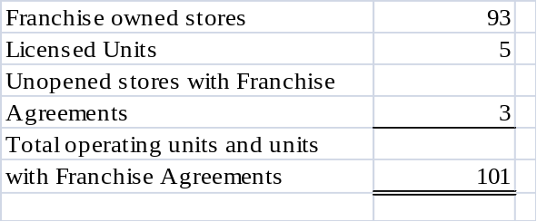
3. Earnings per Share
The following table sets forth the computation of basic and diluted earnings per share:
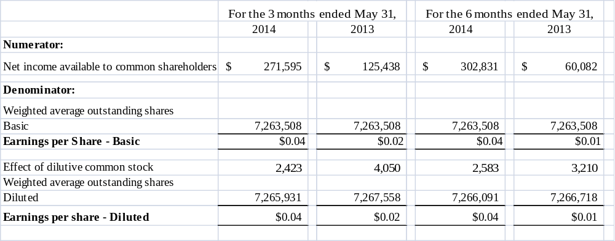
The Company excluded 314,400 and 350,400 potential shares attributable to outstanding stock options from the calculation of diluted earnings per share for the three and six months ended May 31, 2014 and 2013, respectively because their inclusion would have been anti-dilutive.

4. Long-Term Debt
The total debt balance of $95,762 represents a note payable to a former shareholder that requires an annual payment of $35,000, including interest at 4.75%, due October 1 and running through 2016.
5. Stock Options
In May 2001, the Company approved a Long-Term Incentive and Stock Option Plan (Plan). The Plan reserved and has issued 1,400,000 shares of common stock for grant. As of May 31, 2014, there were 1,075,600 stock options exercised or forfeited under the Plan.
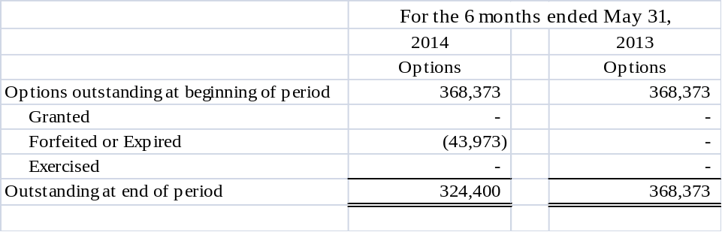
All compensation cost arising from share-based payment arrangements in payroll-related expenses was expensed as of November 30, 2011.
To value option grants and other awards for stock-based compensation, the Company uses the Black-Scholes option valuation model. When the measurement date is certain, the fair value of each option grant is estimated on the date of grant and is based on the assumptions used for the expected stock price volatility, expected term, risk-free interest rates and future dividend payments.

The Company’s stock option terms expire in 10 years and vary in vesting from immediate to a vesting period of five years.

The following table summarizes the stock options outstanding and exercisable at May 31, 2014:
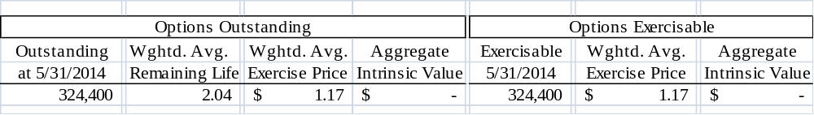

There is no computation for the aggregate intrinsic value in the table above because the outstanding options weighted average exercise price was greater than the Company’s closing stock price of $0.80 as of the last business day of the period ended May 31, 2014. There were 43,973 unexercised options that expired and no options exercised during the six month period ended May 31, 2014.

6. Goodwill and Other Intangible Assets
Accounting Standard Codification (“ASC”) 350 “Goodwill and Other Intangible Assets” requires that assets with indefinite lives no longer be amortized, but instead be subject to annual impairment tests. The Company follows this guidance.

The Company tests goodwill that is not subject to amortization for impairment annually or more frequently if events or circumstances indicate that impairment is possible. Goodwill was tested at the end of the first quarter, February 28, 2014 and it was found that the carrying value of goodwill and intangible assets were not impaired.

The impairment test performed February 28, 2014 was based on a discounted cash flow model using management’s business plan projected for expected cash flows. Based on the computation it was determined that no impairment has occurred.
7. Recent Accounting Pronouncements
Management does not believe that there are any recently issued and effective, or not yet effective, pronouncements as of May 31, 2014 that would have, or are expected to have, any significant effect on the Company’s consolidated financial position, cash flows or results of operations.

8. Equity

On June 13, 2014 the Board of Directions declared a cash dividend/distribution of $0.01 per share to be paid July 16, 2014 to shareholders of record as of June 27, 2014.

On May 6, 2013 BAB, Inc. adopted a Preferred Shares Rights Agreement (“Rights Plan”) and declared a dividend distribution of one right (equivalent to one one-thousandth of a preferred share), for each outstanding share of common stock. The Rights Plan is intended to protect BAB and its stockholders from efforts to obtain control of BAB that the Board of Directors determines are not in the best interest of BAB and its stockholders. BAB issued one right for each current share of stock outstanding at the close of business on May 13, 2013. In general, the rights will not be exercisable unless a person or group acquires 15% (20% institutional investors) or more of BAB’s common stock (“trigger event”). Should a trigger event occur, each right entitles the registered holder to purchase from the Company one one-thousandth of a share of the Series A Participating Preferred Stock of the Company at an exercise price of $0.90 per one-thousandth of a Preferred Share, subject to adjustment. The rights will expire in three years from the date of declaration.

On June 18, 2014 an amendment to the Preferred Shares Rights Agreement was filed appointing American Stock Transfer Company LLC as successor to Illinois Stock Transfer Company. All original rights and provisions remain unchanged.

9. Contingency

We are subject to various legal proceedings and claims, either asserted or unasserted, which arise in the ordinary course of business. While the outcome of such proceedings or claims cannot be predicted with certainty, management does not believe that the outcome of any of such proceedings or claims will have a material effect on our financial position. Except as stated below, we know of no pending or threatened proceeding or claim to which we are or will be a party.

On July 8, 2013, a judgment was entered in the Circuit Court of Cook County in the amount of $84,000 against BAB Operations, Inc. (“Operations”), a wholly owned subsidiary of the Company, and in favor of a former landlord of Operations, Alecta Real Estate USA, LLC. Operations, the subsidiary which owned Company stores, had been a tenant operating a Big Apple Bagels store in Glenview, Illinois from 1999 to 2001 when it sold the store and assigned the lease to a franchisee. The store was sold and the lease was assigned three more times over the next 10 years. In 2011, the final owner of the store closed it and defaulted on the lease. Operations, which no longer owns any Company stores, was sued for a continuing guaranty in connection with the original assignment of the lease in 2001. Operations contended that it bore no liability because of language in one of the subsequent assignments releasing it from any further liability.

On August 15, 2013, an additional judgment of $70,030 was entered in the Circuit Court of Cook County for this same matter for plaintiff’s attorney’s fees bringing the total judgment to $154,030. In September 2013 the Company filed an appeal. A bond was required and posted by BAB, Inc. for an amount equal to 150% of the judgment.

The Company has filed its initial appellate brief. The Plaintiff’s brief was filed on June 27, 2014 and the Company’s reply brief is due on July 11, 2014. It is anticipated that the oral argument, if allowed, would be sometime in September of 2014.

The Company and its trial and appellate counsel believe that we will prevail on appeal and that it is only reasonably possible that the Court’s ruling will be upheld as it is contrary to applicable Illinois precedent. The Company believes there will be zero damages assessed based on prior favorable rulings in similar cases; accordingly, no amounts have been accrued for any potential losses in this matter.

ITEM 2. | MANAGEMENT'S DISCUSSION AND ANALYSIS OF FINANCIAL CONDITION AND RESULTS OF OPERATIONS
Certain statements contained in Management's Discussion and Analysis of Financial Condition and Results of Operations, including statements regarding the development of the Company's business, the markets for the Company's products, anticipated capital expenditures, and the effects of completed and proposed acquisitions, and other statements contained herein regarding matters that are not historical facts, are forward-looking statements as is within the meaning of Section 27A of the Securities Act of 1933 and Section 21E of the Securities Exchange Act of 1934. Because such statements include risks and uncertainties, actual results could differ materially from those expressed or implied by such forward-looking statements as set forth in this report, the Company's Annual Report on Form 10-K and other reports that the Company files with the Securities and Exchange Commission. Certain risks and uncertainties are wholly or partially outside the control of the Company and its management, including its ability to attract new franchisees; the continued success of current franchisees; the effects of competition on franchisees and Company-owned store results; consumer acceptance of the Company's products in new and existing markets; fluctuation in development and operating costs; brand awareness; availability and terms of capital; adverse publicity; acceptance of new product offerings; availability of locations and terms of sites for store development; food, labor and employee benefit costs; changes in government regulation (including increases in the minimum wage); regional economic and weather conditions; the hiring, training, and retention of skilled corporate and restaurant management; and the integration and assimilation of acquired concepts. Accordingly, readers are cautioned not to place undue reliance on these forward-looking statements, which reflect management's analysis only as of the date hereof. The Company undertakes no obligation to publicly release the results of any revision to these forward-looking statements which may be made to reflect events or circumstances after the date hereof or to reflect the occurrence of unanticipated events.
General
There are 93 franchised and 5 licensed units at both May 31, 2014 and 2013. System-wide revenues for the six months ended May 31, 2014 were $17.5 million as compared to May 31, 2013 which were $18.1 million.
The Company's revenues are derived primarily from the ongoing royalties paid to the Company by its franchisees and receipt of initial franchise fees. Additionally, the Company derives revenue from the sale of licensed products (My Favorite Muffin mix, Big Apple Bagels cream cheese and Brewster's coffee), and through licensing and nontraditional channels of distribution (Kohr Bros., Kaleidoscoops, Green Beans Coffee and Sodexo). Also included in licensing fees and other income is Operation’s Sign Shop revenue. The Sign Shop provides the majority of signage, which includes but is not limited to, posters, menu panels, outside window stickers and counter signs to franchisees to provide consistency and convenience.
Royalty fees represent a 5% fee on net retail and wholesale sales of franchised units. Royalty revenues are recognized on an accrual basis using actual franchise receipts. Generally, franchisees report and remit royalties on a weekly basis. The majority of month-end receipts are recorded on an accrual basis based on actual numbers from reports received from franchisees shortly after the month-end. Estimates are utilized in certain instances where actual numbers have not been received and such estimates are based on the average of the last 10 weeks’ actual reported sales.

The Company recognizes franchise fee revenue upon the opening of a franchise store or upon the signing of a master franchise agreement. Direct costs associated with the franchise sale are deferred until the franchise fee revenue is recognized. These costs include site approval, construction approval, commissions, blueprints and training costs.

The Company earns a licensing fee from the sale of BAB branded products, which includes coffee, cream cheese, muffin mix and frozen bagels from a third-party commercial bakery, to the franchised and licensed units.

As of May 31, 2014, the Company employed 11 full-time and 4 part-time employees at the Corporate office. The employees are responsible for corporate management and oversight, accounting, advertising and franchising. None of the Company's employees are subject to any collective bargaining agreements and management considers its relations with its employees to be good.
Results of Operations
Three Months Ended May 31, 2014 versus Three Months Ended May 31, 2013
For the three months ended May 31, 2014 and 2013, the Company reported net income of $272,000 and $125,000, respectively. Total revenue of $769,000 increased $111,000, or 16.9%, for the three months ended May 31, 2014, as compared to total revenue of $658,000 for the three months ended May 31, 2013.
Royalty fee revenue of $456,000, for the quarter ended May 31, 2014, decreased $12,000, or 2.6%, from the $468,000 for quarter ended May 31, 2013. Sales were down because of the extreme winter weather extending into March and April of 2014 versus same period 2013.
Franchise fee revenues of $200,000, for the quarter ended May 31, 2014, increased $190,000 as compared to the same quarter 2013. An International Master Franchise Agreement was signed with a UAE franchisee. According to the terms of the Agreement, BAB will receive franchise royalties from all stores that open under the Agreement. There were two store transfers during the quarter ended May 31, 2013.
Licensing fee and other income of $113,000, for the quarter ended May 31, 2014, decreased $68,000, or 37.6% from $181,000 for the quarter ended May 31, 2013. The decrease in licensing fees and settlement revenues was primarily due to a $13,000 reduction in license fees and no settlement income for 2014 versus $53,000 of settlement income for the quarter ended May 31, 2013. Sign Shop revenue decreased $1,000 for the 3 months ended May 31, 2014 compared to 2013.
Total operating expenses of $482,000 decreased $49,000, or 9.2%, for the quarter ended May 31, 2014, from $531,000 for the same period 2013. The decrease in total operating expenses in 2014 as compared to same period 2013 was primarily due to a decrease in payroll expenses of $72,000, which included a decrease in executive payroll and a decrease in employees which included one SweetDuet employee from this period to same period 2013, offset by decreased Marketing Fund allocations primarily because employee reductions included Marketing personnel. Advertising expenses decreased $11,000 primarily due to a reduction of franchise sales advertising for SweetDuet, Big Apple Bagels and My Favorite Muffin, offset by an increase in the provision for uncollectible accounts of $22,000 in 2014, an increase of $6,000 for occupancy expense and a $5,000 increase in professional fees as compared to the same period 2013.
Interest income was less than $1,000 for the three months ended May 31, 2014 and 2013.
Interest expense was $1,000 for the quarters ended May 31, 2014 and 2013.

There was an income tax expense of $15,000 for the three months ended May 31, 2014 and none for the same period 2013.
Earnings per share, as reported for basic and diluted outstanding shares for the second quarter ended May 31, 2014 was $.04 compared to $0.02 in 2013.
Six Months Ended May 31, 2014 versus Six Months Ended May 31, 2013
For the six months ended May 31, 2014 and 2013, the Company reported net income of $303,000 and $60,000, respectively. Total revenue of $1,306,000 increased $113,000, or 9.5%, for the six months ended May 31, 2014, as compared to total revenue of $1,193,000 for the six months ended May 31, 2013.
Royalty fee revenue of $853,000, for the six months ended May 31, 2014, decreased $34,000, or 3.8%, from the $887,000 for the six months ended May 31, 2013. Sales were down because of the extreme winter weather extending in 2014 compared to 2013.
Franchise fee revenues of $235,000, for the six months ended May 31, 2014, increased $225,000 as compared to the same quarter 2013. One store opened, two stores transferred and an International Master Franchise Agreement was signed with a UAE franchisee in 2014. According to the terms of the Agreement, BAB will receive franchise royalties from all stores that open under the Agreement. There were two store transfers totaling $10,000 in franchise fee revenue during the six months ended May 31, 2013.
Licensing fee and other income of $218,000, for the six months ended May 31, 2014, decreased $78,000, from $296,000 for the six months ended May 31, 2013. There was no settlement and termination income in 2014 versus $53,000 for the six months ended May 31, 2013. Licensing fee revenue decreased $27,000 for the six months in 2014 compared to the same period 2013, offset by an increase of $4,000 for Sign Shop revenue in 2014 compared to the same period 2013.
Total operating expenses of $986,000 decreased $145,000, or 12.8%, for the six months ended May 31, 2014, from $1,131,000 for the same period 2013. The decrease in total operating expenses in 2014 as compared to same period 2013 was primarily due to a decrease of $161,000 for payroll expense due primarily to a reduction in executive salaries, reduction of bonuses and a reduction in number of employees, offset by a reduction in Marketing Fund allocations. Advertising and promotions decreased by $21,000 primarily due to a reduction in SweetDuet, Big Apple Bagels and My Favorite Muffin franchise sales advertising in 2014 compared to same period 2013. Travel decreased by $9,000 for 2014 compared to same period of 2013, offset by an increase in the provision for uncollectible accounts of $22,000 in 2014 compared to same period 2013 and a $5,000 increase in expenses for franchise development in 2014 compared to same period 2013 primarily for SweetDuet.
Interest income was less than a $1,000 for the six months ended May 31, 2014 and 2013.
Interest expense for the six months ended May 31, 2014 and 2013 was $2,000 and $3,000, respectively.
An income tax expense was recorded in the amount of $15,000 for the six months ended May 31, 2014 versus none in 2013.
Earnings per share, as reported for basic and diluted outstanding shares for the six months ended May 31, 2014 and 2013 was $0.04 and $0.01, respectively.

Liquidity and Capital Resources
At May 31, 2014, the Company had working capital of $760,000 and unrestricted cash of $609,000. At November 30, 2013 the Company had working capital of $741,000 and unrestricted cash of $684,000.

During the six months ended May 31, 2014, the Company had net income of $303,000 and operating activities provided cash of $219,000. The principal adjustments to reconcile net income to cash used in operating activities were depreciation and amortization of $9,000 and provision for uncollectible accounts of $22,000. In addition, changes in operating assets and liabilities decreased cash by $115,000. During May 31, 2013, the Company had net income of $60,000 and operating activities provided cash of $52,000. The principal adjustments to reconcile net income to cash provided by operating activities for the three months ending May 31, 2013 were depreciation and amortization of $9,000 less the provision for uncollectible accounts of $6,000. In addition changes in operating assets and liabilities increased cash by $11,000.

For the six months ended May 31, 2014 the Company used $3,000 for investing activities versus $1,000 for the six
months ended May 31, 2013.

The Company used $291,000 and $436,000 for cash distribution/dividend payments during the six month period ended May 31, 2014 and 2013, respectively.

Although there can be no assurances that the Company will be able to pay cash distributions/dividends in the future, it is the Company’s intent that future cash distributions/dividends will be considered based on profitability expectations and financing needs and will be declared at the discretion of the Board of Directors. It is the Company’s intent going forward to declare and pay cash distributions/dividends on a quarterly basis if warranted. On June 13, 2014, the Board of Directors authorized a $0.01 per share cash distribution/dividend payable July 16, 2014 to shareholders of record as of June 27, 2014.

The Company believes execution of its cash distribution/dividend policy will not have any material adverse effects on its cash or its ability to fund current operations or future capital investments.

The Company has no financial covenants on its outstanding debt.

Cash Distribution and Dividend Policy
It is the Company’s intent that future cash distributions/dividends will be considered after reviewing profitability expectations and financing needs and will be declared at the discretion of the Board of Directors. Due to the general economic downturn and its impact on the Company, there can be no assurance that the Company will generate sufficient earnings to pay out cash distributions/dividends. The Company will continue to analyze its ability to pay cash distributions/dividends on a quarterly basis.
The Company believes that for tax purposes the cash distributions declared in 2014 may be treated as a return of capital to stockholders depending on each stockholder’s basis or it may be treated as a dividend or a combination of the two. Determination of whether it is a cash distribution, cash dividend or combination of the two will not be made until after December 31, 2014, as the classification or combination is dependent upon the Company’s earnings and profits for tax purposes for its fiscal year ending November 30, 2014.
The Company believes execution of this policy will not have any material adverse effect on its ability to fund current operations or future capital investments.

Recent Accounting Pronouncements
Management does not believe that there are any recently issued and effective, or not yet effective, pronouncements as of May 31, 2014 that would have, or are expected to have, any significant effect on the Company’s consolidated financial position, cash flows or results of operations.

Critical Accounting Policies
The Company has identified significant accounting policies that, as a result of the judgments, uncertainties, uniqueness and complexities of the underlying accounting standards and operations involved could result in material changes to its financial condition or results of operations under different conditions or using different assumptions. The Company's most critical accounting policies are related to revenue recognition, valuation of long-lived and intangible assets, deferred tax assets and the related valuation allowance. Details regarding the Company's use of these policies and the related estimates are described in the Company's Annual Report on Form 10-K for the fiscal year ended November 30, 2013, filed with the Securities and Exchange Commission on February 26, 2014. There have been no material changes to the Company's critical accounting policies that impact the Company's financial condition, results of operations or cash flows for the six months ended May 31, 2014.

ITEM 3. | QUANTITATIVE AND QUALITATIVE DISCLOSURE ABOUT MARKET RISK
BAB, Inc. has no interest, currency or derivative market risk.

ITEM 4. | CONTROLS AND PROCEDURES

Evaluation of Disclosure Controls and Procedures

Our management, with the participation of both our Chief Executive Officer and Chief Financial Officer, has evaluated the effectiveness of our disclosure controls and procedures (as defined in Rules 13a-15(e) under the Securities and Exchange Act of 1934, as amended (the “Exchange Act”), as of the end of the period covered by this report. Based on such evaluation, both our Chief Executive Officer and Chief Financial Officer have concluded that, as of May 31, 2014 our disclosure controls and procedures are effective (i) to ensure that information required to be disclosed by us in the reports that we file or submit under the Exchange Act is recorded, processed, summarized and reported within the time periods specified in the SEC’s rules and forms and (ii) to ensure that information required to be disclosed by us in the reports that we submit under the Exchange Act is accumulated and communicated to our management, including our executive and financial officers, or persons performing similar functions, as appropriate, to allow timely decisions regarding required disclosure.
Changes in Internal Control Over Financial Reporting
In March 2014 the Chief Financial Officer left the Company and the Controller was promoted to that position. An individual was hired in a part-time position and duties/control procedures have been reallocated and there is appropriate internal controls over financial reporting (as such term is defined in Rules 13a-15(f) and 15(d)-15(f) under the Exchange Act) during the three months of fiscal year 2014 to which this report relates. There are no internal control changes during the six months of fiscal 2014 that have materially affected, or are reasonably likely to materially affect, our internal control over financial reporting.

Compliance with Section 404 of Sarbanes-Oxley Act

The Company is in compliance with Section 404 of the Sarbanes-Oxley Act of 2002 (the “Act”).

PART II
ITEM 1. | LEGAL PROCEEDINGS

We are subject to various legal proceedings and claims, either asserted or unasserted, which arise in the ordinary course of business. While the outcome of such proceedings or claims cannot be predicted with certainty, management does not believe that the outcome of any of such proceedings or claims will have a material effect on our financial position. Except as stated below, we know of no pending or threatened proceeding or claim to which we are or will be a party.

On July 8, 2013, a judgment was entered in the Circuit Court of Cook County in the amount of $84,000 against BAB Operations, Inc. (“Operations”), a wholly owned subsidiary of the Company, and in favor of a former landlord of Operations, Alecta Real Estate USA, LLC. Operations, the subsidiary which owned Company stores, had been a tenant operating a Big Apple Bagels store in Glenview, Illinois from 1999 to 2001 when it sold the store and assigned the lease to a franchisee. The store was sold and the lease was assigned three more times over the next 10 years. In 2011, the final owner of the store closed it and defaulted on the lease. Operations, which no longer owns any Company stores, was sued for a continuing guaranty in connection with the original assignment of the lease in 2001. Operations contended that it bore no liability because of language in one of the subsequent assignments releasing it from any further liability.

On August 15, 2013, an additional judgment of $70,030 was entered in the Circuit Court of Cook County for this same matter for plaintiff’s attorney’s fees bringing the total judgment to $154,030. In September 2013 the Company filed an appeal. A bond was required and posted by BAB, Inc. for an amount equal to 150% of the judgment.

The Company has filed its initial appellate brief. The Plaintiff’s brief was filed on June 27, 2014 and the Company’s reply brief is due on July 11, 2014. It is anticipated that the oral argument, if allowed, would be sometime in September of 2014.

The Company and its trial and appellate counsel believe that we will prevail on appeal and that it is only reasonably possible that the Court’s ruling will be upheld as it is contrary to applicable Illinois precedent. The Company believes there will be zero damages assessed based on prior favorable rulings in similar cases; accordingly, no amounts have been accrued for any potential losses in this matter.

ITEM 2. | UNREGISTERED SALES OF EQUITY AND USE OF PROCEEDS
None.
ITEM 3. | DEFAULTS UPON SENIOR SECURITIES
None.
ITEM 4. | MINE SAFETY DISCLOSURES
Not applicable
ITEM 5. | OTHER INFORMATION
None.
ITEM 6. | EXHIBITS
See index to exhibits

SIGNATURE
In accordance with the requirements of the Exchange Act, the registrant has duly caused this report to be signed on its behalf by the undersigned, thereunto duly authorized.
BAB, Inc.
Dated: July 11, 2014 | /s/ Geraldine Conn
 | Geraldine Conn
 | Chief Financial Officer

INDEX TO EXHIBITS
(a) EXHIBITS
The following exhibits are filed herewith.
 | INDEX NUMBER | DESCRIPTION
 | 21.1 | List of Subsidiaries of the Company
 | 31.1 | Section 302 of the Sarbanes-Oxley Act of 2002 Certification of Chief Executive Officer
 | 31.2 | Section 302 of the Sarbanes-Oxley Act of 2002 Certification of Chief Financial Officer
 | 32.1 | Section 906 of the Sarbanes-Oxley Act of 2002 Certification of Chief Executive Officer
 | 32.2 | Section 906 of the Sarbanes-Oxley Act of 2002 Certification of Chief Financial Officer
 | Exhibit 21.1
SUBSIDIARIES OF BAB, INC.

BAB Systems, Inc., an Illinois corporation
BAB Operations, Inc., an Illinois corporation
BAB Investments, Inc., an Illinois corporation

Exhibit 31.1
CERTIFICATION OF THE CHIEF EXECUTIVE OFFICER PURSUANT TO RULE 13A-14 (a) OR RULE 15d-14 (a) OF THE SECURITIES EXCHANGE ACT OF 1934.
I, Michael W. Evans, certify that:
- I have reviewed this quarterly report on Form 10-Q of BAB, Inc.
- Based on my knowledge, this report does not contain any untrue statement of a material fact or omit to state a material fact necessary to make the statements made, in light of the circumstances under which such statements were made, not misleading with respect to the period covered by this report;
- Based on my knowledge, the financial statements, and other financial information included in this report, fairly present in all material respects the financial condition, results of operations and cash flows of the registrant as of, and for, the periods presented in this report;
- The registrant’s other certifying officer(s) and I are responsible for establishing and maintaining disclosure controls and procedures (as defined in Exchange Act Rules 13a -15(e) and 15d -15(e)) and internal control over financial reporting (as defined in Exchange Act Rules 13a – 15(f) and 15d -15(f)) for the registrant and have:
  - Designed such disclosure controls and procedures, or caused such disclosure controls and procedures to be designed under our supervision, to ensure that material information relating to the registrant, including its consolidated subsidiaries, is made known to us by others within those entities, particularly during the period in which this report is being prepared;
  - Designed such internal control over financial reporting, or caused such internal control over financial reporting to be designed under our supervision, to provide reasonable assurance regarding the reliability of financial reporting and the preparation of financial statements for external purposes in accordance with generally accepted accounting principles;
  - Evaluated the effectiveness of the registrant’s disclosure controls and procedures and presented in this report our conclusions about the effectiveness of the disclosure controls and procedures, as of the end of the period covered by this report based on such evaluation; and
  - Disclosed in this report any change in the registrant’s internal control over financial reporting that occurred during the registrant’s most recent fiscal quarter (the registrant’s fourth fiscal quarter in the case of an annual report) that has materially affected, or is reasonably likely to materially affect, the registrant’s internal control over financial reporting; and
- The registrant’s other certifying officer(s) and I have disclosed, based on our most recent evaluation of internal control over financial reporting, to the registrant’s auditors and the audit committee of the registrant’s board of directors (or persons performing the equivalent functions):
  - All significant deficiencies and material weaknesses in the design or operation of internal control over financial reporting which are reasonably likely to adversely affect the registrant’s ability to record, process, summarize and report financial information; and
  - Any fraud, whether or not material, that involves management or other employees who have a significant role in the registrant’s internal control over financial reporting.

Date: July 11, 2014 by / s/ Michael W. Evans
Michael W. Evans, Chief Executive Officer

Exhibit 31.2
CERTIFICATION OF CHIEF FINANCIAL OFFICER PURSUANT TO RULE 13A-14 (a) OR RULE 15d-14 (a) OF THE SECURITIES EXCHANGE ACT OF 1934.
I, Geraldine Conn, certify that:
- I have reviewed this quarterly report on Form 10-Q of BAB, Inc.
- Based on my knowledge, this report does not contain any untrue statement of a material fact or omit to state a material fact necessary to make the statements made, in light of the circumstances under which such statements were made, not misleading with respect to the period covered by this report;
- Based on my knowledge, the financial statements, and other financial information included in this report, fairly present in all material respects the financial condition, results of operations and cash flows of the small business issuer as of, and for, the periods presented in this report;
- The registrant’s other certifying officer(s) and I are responsible for establishing and maintaining disclosure controls and procedures (as defined in Exchange Act Rules 13a -15(e) and 15d -15(e)) and internal control over financial reporting (as defined in Exchange Act Rules 13a–15(f) and 15d -15(f)) for the registrant and have:
  - Designed such disclosure controls and procedures, or caused such disclosure controls and procedures to be designed under our supervision, to ensure that material information relating to the registrant, including its consolidated subsidiaries, is made known to us by others within those entities, particularly during the period in which this report is being prepared;
  - Designed such internal control over financial reporting, or caused such internal control over financial reporting to be designed under our supervision, to provide reasonable assurance regarding the reliability of financial reporting and the preparation of financial statements for external purposes in accordance with generally accepted accounting principles;
  - Evaluated the effectiveness of the registrant’s disclosure controls and procedures and presented in this report our conclusions about the effectiveness of the disclosure controls and procedures, as of the end of the period covered by this report based on such evaluation; and
  - Disclosed in this report any change in the registrant’s internal control over financial reporting that occurred during the registrant’s most recent fiscal quarter (the registrant’s fourth fiscal quarter in the case of an annual report) that has materially affected, or is reasonably likely to materially affect, the registrant’s internal control over financial reporting; and
- The registrant’s other certifying officer and I have disclosed, based on our most recent evaluation of internal control over financial reporting, to the registrant’s auditors and the audit committee of the registrant’s board of directors (or persons performing the equivalent functions):
  - All significant deficiencies and material weaknesses in the design or operation of internal control over financial reporting which are reasonably likely to adversely affect the registrant’s ability to record, process, summarize and report financial information; and
  - Any fraud, whether or not material, that involves management or other employees who have a significant role in the registrant’s internal control over financial reporting.

Date: July 11, 2014 By: /s/ Geraldine Conn
Geraldine Conn, Chief Financial Officer

Exhibit 32.1
BAB, Inc.
CERTIFICATION PURSUANT TO 18 U.S.C. SECTION 1350
AS ADOPTED PURSUANT TO SECTION 906 OF THE SARBANES-OXLEY ACT OF 2002
In connection with the BAB, Inc. (the "Company") Quarterly Report on Form 10-Q for the period ended May 31, 2014, as filed with the Securities and Exchange Commission on the date hereof (the "Report"), I, Michael W. Evans, Chief Executive Officer of the Company, certify pursuant to 18 U.S.C. Section 1350, as adopted pursuant to Section 906 of the Sarbanes-Oxley Act of 2002, that, to the best of my knowledge:
- The Report fully complies with the requirements of section 13(a) or 15(d) of the Securities and Exchange Act of 1934, as amended; and
- The information contained in the Report fairly presents, in all material respects, the financial condition, results of operations, and cash flows of the Company.
Date: July 11, 2014 By: /s/ Michael W. Evans
Michael W. Evans, Chief Executive Officer

Exhibit 32.2

BAB, Inc.
CERTIFICATION PURSUANT TO 18 U.S.C. SECTION 1350
AS ADOPTED PURSUANT TO SECTION 906 OF THE SARBANES-OXLEY ACT OF 2002
In connection with the BAB, Inc. (the "Company") Quarterly Report on Form 10-Q for the period ended May 31, 2014, as filed with the Securities and Exchange Commission on the date hereof (the "Report"), I, Geraldine Conn, Chief Financial Officer of the Company, certify pursuant to 18 U.S.C. Section 1350, as adopted pursuant to Section 906 of the Sarbanes-Oxley Act of 2002, that, to the best of my knowledge:
- The Report fully complies with the requirements of section 13(a) or 15(d) of the Securities and Exchange Act of 1934, as amended; and
- The information contained in the Report fairly presents, in all material respects, the financial condition, results of operations, and cash flows of the Company.

Date: July 11, 2014 By: /s/ Geraldine Conn
Geraldine Conn, Chief Financial Officer

